AcknoWledgement
The satisfaction that accompanies the successful completion of this project would be incomplete without mentioning the people who made it possible, without whose constant guidance and encouragement would have made efforts go in vain. I consider myself privileged to express gratitude and respect towards all those who have guided through the completion of projects.
I convey thanks to my project guide Prof.(Dr.) Anshuman Kalla, Computer Engineering/Artificial Intelligence & Data Science department, CGPIT for providing encouragement, constant support, and guidance which was of great help in completing this project work successfully.
I am grateful to my external guide Mr. Suraj Kalgude, Head of Devops for giving me the support and encouragement that was necessary for the completion of this project.
I am grateful to Dr. Vibha Patel, Head of the Department, Computer Engineering/Artificial Intelligence & Data Science department, CGPIT for giving us the support and encouragement that was necessary for the completion of this project.
I would also like to express my gratitude to Prof. B.M.Vadher, Director, Chhotubhai Gopalbhai Patel Institute of Technology for providing us congenial environment to work in.
I would like to thank all the faculty members for their patience, understanding and guidance that gave me strength and will power to work through the long tedious hours for developing a project and preparing the report.
Last but not the least, I would also like to thank my colleagues, who have co-operated during the preparation of our report and without them this project has not been possible. Their ideas helped me a lot to improve my project report.

Dhruvil Miyani (202003103510221)

Abstract
Continuous Integration (CI) and Continuous Delivery (CD) pipelines have emerged as pivotal methodologies in modern software development, enabling rapid and reliable software delivery. This abstract provides a comprehensive overview of CI/CD pipelines, emphasizing their significance, components, and implementation strategies.
CI/CD pipelines streamline the software development lifecycle by automating the integration and deployment processes. Continuous Integration focuses on the frequent merging of code changes into a shared repository, where each integration is automatically built and tested. This practice aims to detect integration issues early, ensuring that the codebase remains in a deployable state. Key components of CI include version control systems, automated build tools, and testing frameworks. Version control systems, such as Git, facilitate collaborative development by managing code changes, while automated build tools compile the code and generate executable files. Testing frameworks, integral to CI, run unit, integration, and regression tests to validate code quality.
Continuous Delivery extends CI by automating the deployment process, ensuring that code changes can be safely and swiftly deployed to production. CD pipelines encompass stages like build, test, and deploy, with each stage designed to enforce quality and security standards. Deployment automation tools, such as Jenkins, GitLab CI/CD, and CircleCI, play a crucial role in orchestrating these stages, minimizing human intervention, and reducing the risk of errors. Additionally, CD practices include continuous monitoring and feedback loops, which provide insights into application performance and user experience, facilitating iterative improvements.
Implementing an effective CI/CD pipeline involves several best practices. These include maintaining a single source of truth for code, using environment parity to ensure consistency across development, testing, and production environments, and incorporating automated testing and monitoring to catch issues early. Furthermore, integrating security checks into the pipeline—known as DevSecOps—ensures that security is an integral part of the development process, rather than an afterthough.

Table of Contents

ACKNOWLEDGEMENT v
ABSTRACT. vi
LIST OF FIGURES ix
LIST OF TABLES xi
CHAPTER 1 INTRODUCTION 1
1.1 PROBLEM DEFINITION 1
1.1 SCOPE 1
1.2 OBJECTIVE 2
CHAPTER 2 TRAINING ACTIVITES 3
2.1 AWS SERVICES 3
2.1.1 Code pipeline 3
2.1.2 Code Build 4
2.1.3 Code Deploy 4
2.1.4 S3 Bucket 4
2.1.5 EC2 Instance 5
2.1.6 SNS(Simple Notification Services) 5
2.1.7 AWS Backup 5
2.2 STAGES IN DEVELOPMENT & OPERATIONS 6
2.2.1 Hosting proxy site on EC2 instance 6
2.2.2 Downloading SSL certificate of hosted React Site 7
2.2.3 Backup Of RDS in S3 Bucket 9
CHAPTER 3 SYSTEM PLANNING 12
3.1 AGILE 12
3.1.1 Advantages od Agile Model: 13
3.1.2 Disadvantages of Agile Model: 14
3.2 Timeline Chart 15
CHAPTER 4 PROJECT DEVELOPMENT & TESTING 16
4.1 CONTINUOUS INTEGRATION & DEVELOPMENT 16
4.1.1 Visual Studio Code 17
4.1.2 GitHub 17
4.1.3 Code Build 18
4.2 CONTINUOUS TESTING 21
4.2.1 UI-TESTING 21
4.2.2 Load Testing 25
CHAPTER 5 DEPLOYMENT AND MONITORING 28
5.1 CONTINUOUS DEPLOYMENT 28
5.1.1 Code Deploy 28
5.1.2 CODE DEPLOYMENT ON EC2 INSTANCE 31
5.2 CONTINUOUS FEEDBACK 33
5.2.1 SNS(SIMPLE NOTIFICATION SERVICE) 34
5.2.2 Discord 36
5.3 COTINUOUS MONITORING 39
5.3.1 GRAFANA 39
CHAPTER 6 CONCLUSION AND FUTURE SCOPE 44
6.1 CONCLUSION 44
6.2 FUTURE SCOPE 45
REFERENCES 46

List of Figures
Figure 2-1 Config file in Ngnix server 6
Figure 2-2 Host File In Local Machine 7
Figure 2-3 SSL forfree Authentication For Certificate 7
Figure 2-4 Uploading HTTP File In Public Folder 8
Figure 2-5 NgnixConfig File 8
Figure 2-6 Uploading Certificate to EC2 instance 8
Figure 2-7 Site With Certificate 9
Figure 2-8 Command To upload Backup In S3 Bucket 10
Figure 2-9 Backup Uploaded in S3 Bucket 11
Figure 4-1 CodePipeline Flow Chart 16
Figure 4-2 Eslint code File 17
Figure 4-3 Branch Protection 18
Figure 4-4 Buildspec.yml file 19
Figure 4-5 AWS System Manager 20
Figure 4-6 Docker Repository 20
Figure 4-7 Build Artifacts 20
Figure 4-8 Lambda Function Code 21
Figure 4-9 Pipeline Connection with Ghost Inspector 23
Figure 4-10 Ghost Inspector Test Site 24
Figure 4-11 Ghost Inspector Test Result 24
Figure 4-12 Dashboard of Result Generated from JMeter Test 26
Figure 4-13 JMeter Config File 27
Figure 4-14 CSV File Output 27
Figure 4-15 Lambda Function Code For S3 File Deletion 28
Figure 5-1 Deployment Configuration 30
Figure 5-2 Deployment Application 31
Figure 5-3 Lifecycle Events of Code Deployment 31
Figure 5-4 Command to get S3 Bucket 32
Figure 5-5 Status of Code-Agent 33
Figure 5-6 IAM Role Of EC2 Codedeploy 33
Figure 5-7 SNS 34
Figure 5-8 Subscription Of SNS 35
Figure 5-9 Code Deploy Notification Rule 36
Figure 5-10 Email Notification of Code Pipeline 36
Figure 5-11 Discord Webhook 37
Figure 5-12 CPU Alert Message 37
Figure 5-13 Grafana webhook config 38
Figure 5-14 Grafana on 3000 Port on Instance 40
Figure 5-15 Grafana Dashboard 42
Figure 5-16 Grafana Dashboard 42
Figure 5-17 CI/CD Pipeline 43

List of Tables
Table 3.1 Timelinechart 15

Introduction

PROBLEM DEFINITION
Traditional software development and deployment processes often suffer from inefficiencies, delays, and errors due to manual intervention and lack of automation. Developers face challenges in integrating their code changes smoothly into a shared repository, ensuring consistent builds, and running tests reliably, and deploying updates quickly and consistently. The need for a streamlined and automated approach to software delivery has become paramount to meet the demands of modern development practices and agile methodologies. Hence, the problem at hand is to design and implement a CI/CD pipeline that automates the integration, testing, and delivery processes, enabling continuous integration of code changes, rigorous testing, and seamless deployment to production environments, thereby reducing errors, accelerating time-to-market, and enhancing overall software quality.

SCOPE
The scope of this project encompasses the comprehensive design, implementation, and validation of a Continuous Integration/Continuous Deployment (CI/CD) pipeline tailored for a software development team. The project begins with the selection of the most suitable tools and technologies for CI/CD, including version control systems, build automation tools, testing frameworks, containerization technologies, infrastructure as code (IaC) tools, and monitoring solutions. This selection process ensures that the chosen tools align with the team's specific needs and the overall project requirements.
Following the selection of tools, the project involves architecting the CI/CD pipeline to handle the full software lifecycle, from code commit to deployment in production. This includes defining branching strategies to manage code versions effectively, setting up build automation processes to compile and package code, and implementing automated testing workflows to ensure code quality and reliability. The implementation phase will see the configuration of the CI/CD environment, writing of necessary scripts, and integration of tools to create seamless automated workflows.

A crucial aspect of the scope is the rigorous testing and validation of the pipeline to ensure it operates efficiently, reliably, and securely. This involves conducting various tests at each stage of the pipeline to identify and address any issues early. The project also covers the automation of deployment processes to both staging and production environments, ensuring smooth transitions and minimal downtime during releases. Lastly, the scope includes the establishment of monitoring and feedback mechanisms to track pipeline performance and application health continuously, providing insights for ongoing improvements and ensuring the system remains robust and responsive to changes.

OBJECTIVE
The primary objective of this project is to enhance the software development process by implementing a robust CI/CD pipeline that automates code integration, testing, and deployment. A key objective is to automate the integration of code changes into a shared repository multiple times a day, thereby enabling a Continuous Integration (CI) process that ensures every code change is built and tested automatically. This objective aims to catch integration issues early, reducing the time and effort required to resolve them.
Another critical objective is to establish a comprehensive automated testing framework that includes unit tests, integration tests, and end-to-end tests. This framework will ensure thorough validation of code changes before they reach production, significantly improving code quality and reducing the likelihood of defects. Additionally, the project aims to develop a Continuous Deployment (CD) process that automates the deployment of applications to staging and production environments. By minimizing manual intervention, this objective seeks to reduce deployment errors and accelerate the release process.
Improving reliability and consistency across all environments is also a primary objective. The CI/CD pipeline will ensure that builds and deployments are consistent, reducing the risk of environment-specific issues. Accelerating time-to-market is another key goal, achieved by automating integration, testing, and deployment processes to bring new features and updates to market more quickly. Implementing robust monitoring and feedback mechanisms is essential to track the health and performance of the pipeline and deployed applications, providing real-time insights to the development team.

Training activities

AWS SERVICES

Code pipeline
AWS Code Pipeline is a fully managed continuous integration and continuous delivery (CI/CD) service provided by Amazon Web Services (AWS). It automates the build, test, and deployment phases of your release process every time there is a code change, based on the Release workflow defined.
1.Pipeline: A pipeline represents your CI/CD workflow and consists of a series of stages. Each stage can contain one or more actions, such as source, build, test, and deploy.
2.Source: This stage retrieves the source code from a version control repository such as AWS Code Commit, GitHub, Bit bucket, or Amazon S3. It triggers the pipeline whenever there is a change in the source code repository.
3.Build: The build stage compiles the source code, runs unit tests, and packages the artifacts for deployment. AWS Code Pipeline integrates with AWS Code Build or other third-party Build services like Jenkins.
4.Test: The test stage executes automated tests, including unit tests, integration tests, and any other tests needed to validate the code changes. You can use AWS services like AWSCode Build, AWS Device Farm, or third-party testing tools.
5.Deploy: The deploy stage deploys the artifacts generated in the build stage to the target environment, such as AWS Elastic Beanstalk, Amazon ECS, AWS Lambda, or an on-Premises server. It can also update AWS Cloud Formation stacks or invoke AWS Step Functions.
6.Approval: Optionally, it can include manual approval actions between stages to require human intervention before proceeding with the deployment process.

7.Integration: AWS Code Pipeline seamlessly integrates with other AWS services, enabling you to build end-to-end CI/CD pipelines. It provides features like artifact storage, versioning, and notifications through Amazon SNS or Amazon Cloud Watch Events.
Overall, AWS Code Pipeline simplifies and automates the software release process, enabling teams to deliver changes quickly and reliably while adhering to best practices in CI/CD.

Code Build
AWS Code Build is a fully managed continuous integration service provided by Amazon Web Services (AWS). It compiles source code, runs tests, and produces deployable artifacts without the need for provisioning or managing build servers. Code Build seamlessly integrates with other AWS services and popular source control repositories, allowing developers to focus on writing code while Code Build handles the build and test processes. It scales automatically to accommodate the size and complexity of builds, ensuring fast and reliable build execution

Code Deploy
AWS Code Deploy is a fully managed deployment service provided by Amazon Web Services (AWS) that automates software deployments to a variety of compute services such as Amazon EC2 instances, AWS Lambda functions, and on-premises servers. It simplifies the process of releasing new features, updates, and bug fixes to production environments, enabling developers to deploy applications quickly and reliably.
With AWS Code Deploy, you can deploy code from various sources, including Amazon S3 buckets, GitHub repositories, or Bitbucket repositories. It allows to define deployment configurations that specify how the deployment should proceed, including deployment targets, deployment groups, and deployment settings.
Code Deploy supports both in-place deployments, where the application is updated directly on the target instances, and blue/green deployments, where a new set of instances is provisioned with the updated application before swapping traffic from the old instances to the new ones

S3 Bucket
An Amazon S3 bucket is a cloud storage resource provided by Amazon Web Services (AWS) for storing and retrieving data. It serves as a central repository for storing a wide variety of data types, including documents, images, videos, and application data. S3 buckets are highly

scalable, durable, and secure, making them suitable for a wide range of use cases, from simple file storage to complex data analytics pipelines.

EC2 Instance
Amazon Elastic Compute Cloud (Amazon EC2) is a web service provided by Amazon Web Services (AWS) that enables you to launch and manage virtual servers, known as instances, in the cloud. EC2 instances provide scalable compute capacity and allow you to run a wide variety of applications, from simple web servers to complex data processing workloads.

SNS(Simple Notification Services)
Amazon Simple Notification Service (Amazon SNS) is a fully managed messaging service provided by Amazon Web Services (AWS) that enables you to send messages or notifications to a variety of endpoints, including email, SMS, mobile push, HTTP/HTTPS, and Amazon SQS queues. SNS simplifies the process of sending messages and allows you to decouple the sender from the receiver, making it ideal for building event-driven and distributed systems.

AWS Backup
AWS Backup is a comprehensive solution offered by Amazon Web Services (AWS) that simplifies data protection and management across various AWS services and on-premises environments. With AWS Backup, users can centrally manage backup policies, schedules, and retention settings through a unified console and API, streamlining the backup process. The service seamlessly integrates with popular AWS offerings such as Amazon EBS, RDS, DynamoDB, EFS, and Storage Gateway, allowing users to protect critical data stored in these services effortlessly. Automated backup and restore functionalities enable users to schedule recurring backups and easily recover data in the event of accidental deletion or corruption. Additionally, AWS Backup supports cross-region and cross-account backups, providing data redundancy and disaster recovery capabilities. With built-in encryption, monitoring, and compliance features, AWS Backup ensures data security and regulatory compliance, making it a reliable and cost-effective solution for organizations seeking to safeguard their data assets.

STAGES IN DEVELOPMENT & OPERATIONS

Hosting proxy site on EC2 instance
The react static website was hosted on 3000 port of EC2 instance. Firstly, it was pushed on GitHub and then it is downloaded on instance. Nginx server is being installed on instance. The configuration of site was stored in sites-enabled folder in nginx server where theparticular domain was given for website and the changes were also made in host file of local machine.
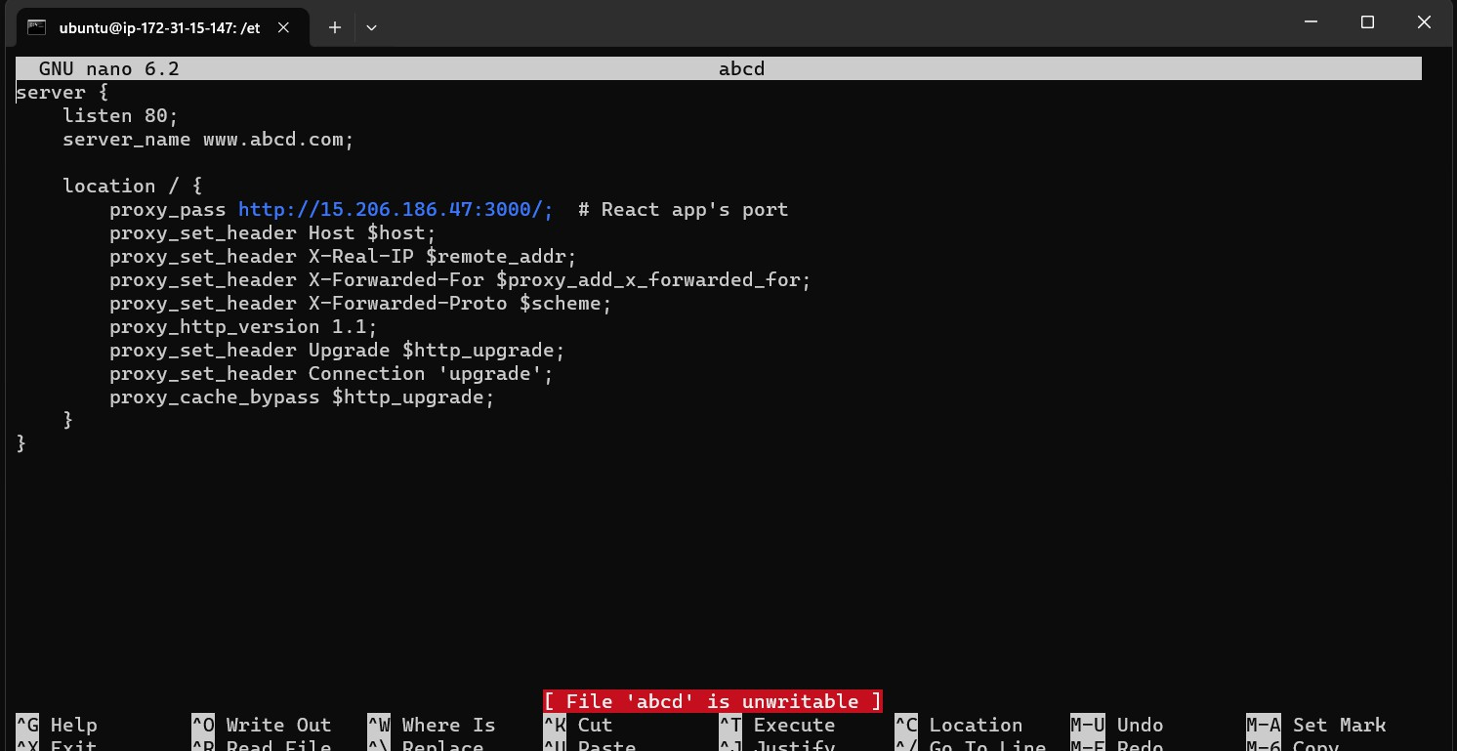

Figure 2-1 Config file in Ngnix server

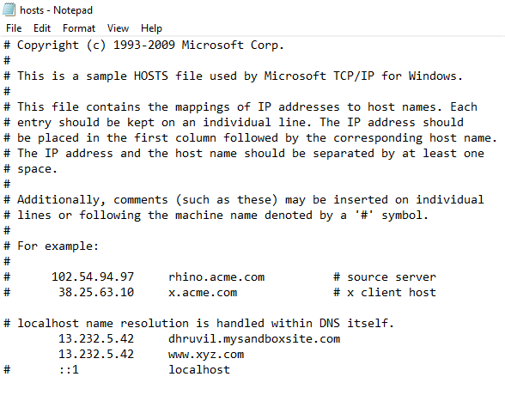

Figure 2-2 Host File In Local Machine

Downloading SSL certificate of hosted React Site
SSL stands for Secure Sockets Layer. It's a standard security protocol used to establish an encrypted link between a web server and a browser. This link ensures that all data passed between the web server and browser remains private and integral.
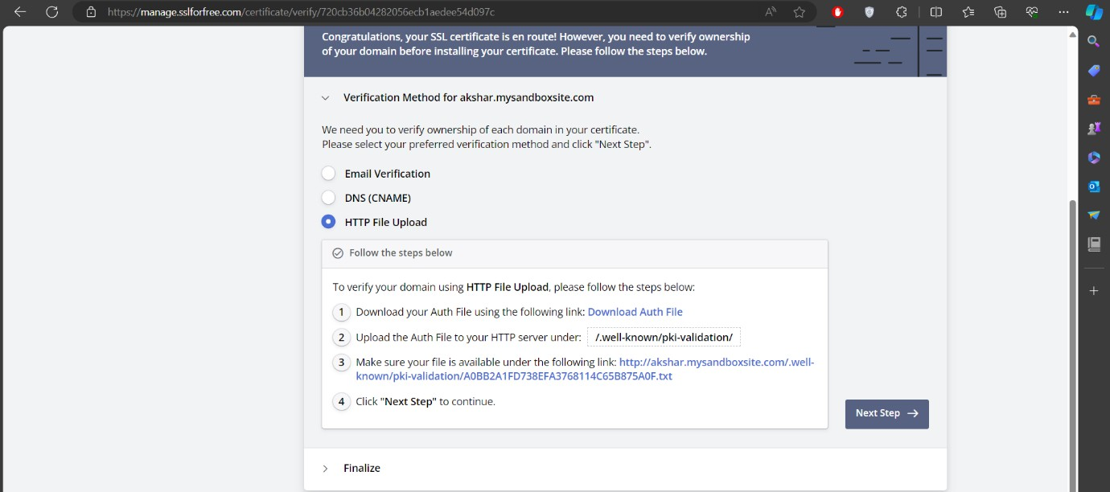
The SSLforfree website provides free ssl certificate for website. The HTTP file should be uploaded in react project of public folder so they can verify the website security.

Figure 2-3 SSL forfree Authentication For Certificate
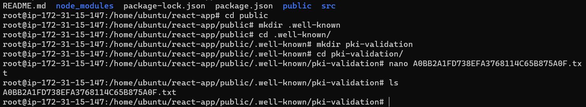
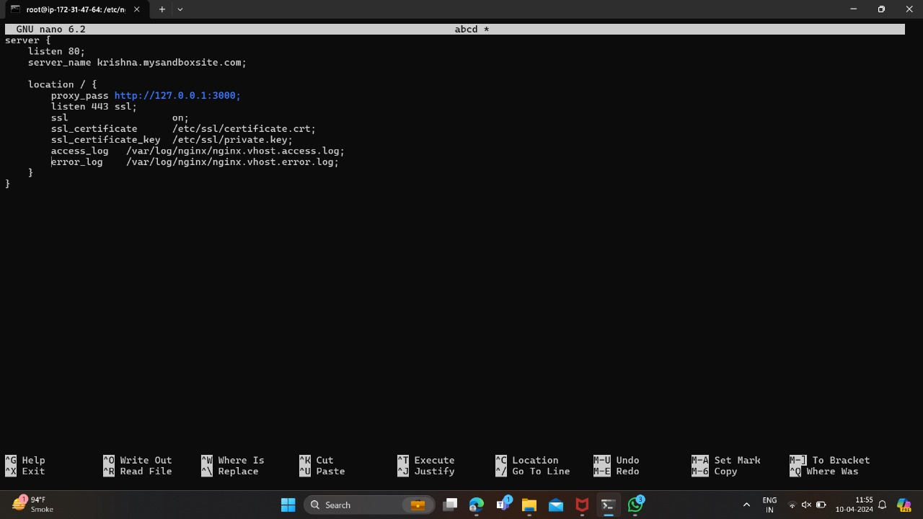
Figure 2-4 Uploading HTTP File In Public Folder

Figure 2-5 NgnixConfig File
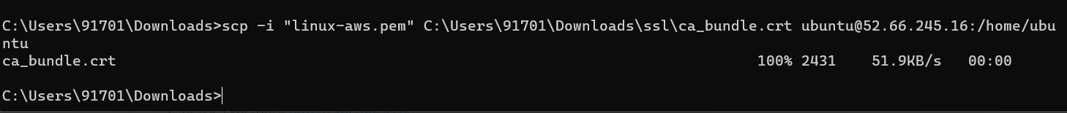
Figure 2-6 Uploading Certificate to EC2 instance

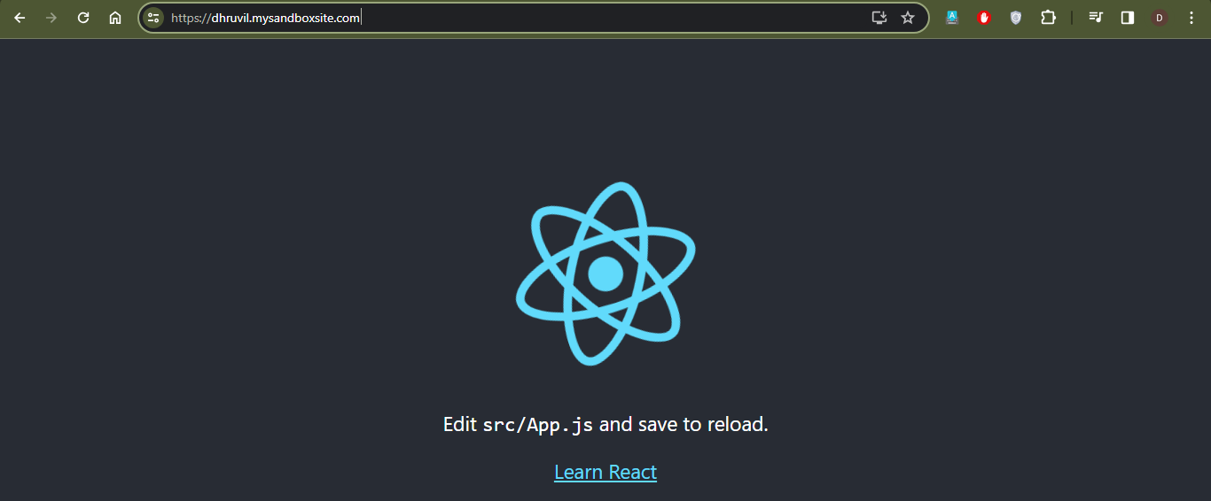
Figure 2-7 Site With Certificate

Backup Of RDS in S3 Bucket
RDS (Microsoft SQL) backup is taken in s3 bucket through local machine using Microsoft SQL management Studio.

Steps to configure RDS:
      - Launch a New RDS Instance
      - Click on "Create database".
      - Select the "Standard create" method.
      - Choose the Microsoft SQL Server engine.
      - Select the edition of SQL Server you want to use (e.g., Express, Standard, Enterprise).
      - Choose the version of SQL Server (e.g., SQL Server 2019, SQL Server 2017, SQL Server 2016).
      - Specify other configuration details such as instance size, storage type, storage size, and database identifier.
      - Provide a unique DB instance identifier.
      - Set the master username and password for the SQL Server instance.
      - Choose the DB instance class and allocate the desired amount of compute and memory resources.

      - Specify the storage type (e.g., General Purpose SSD, Provisioned IOPS SSD) and storage size.
      - Configure the VPC and subnet settings for the RDS instance.
      - Define security groups and network settings to control inbound and outbound traffic to the RDS instance.
      - Configure IAM roles and policies to manage permissions for accessing the RDS resources.
      - Review the configuration settings to ensure they are accurate.
      - Click on "Create database" to launch the RDS instance.

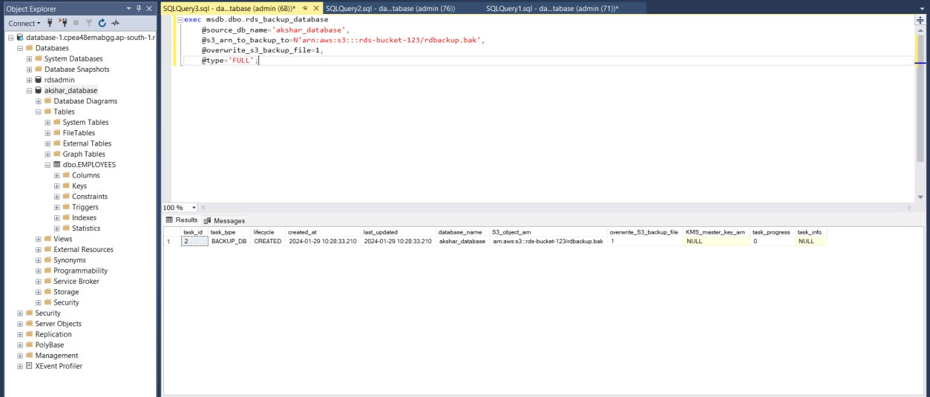
Figure 2-8 Command To upload Backup In S3 Bucket

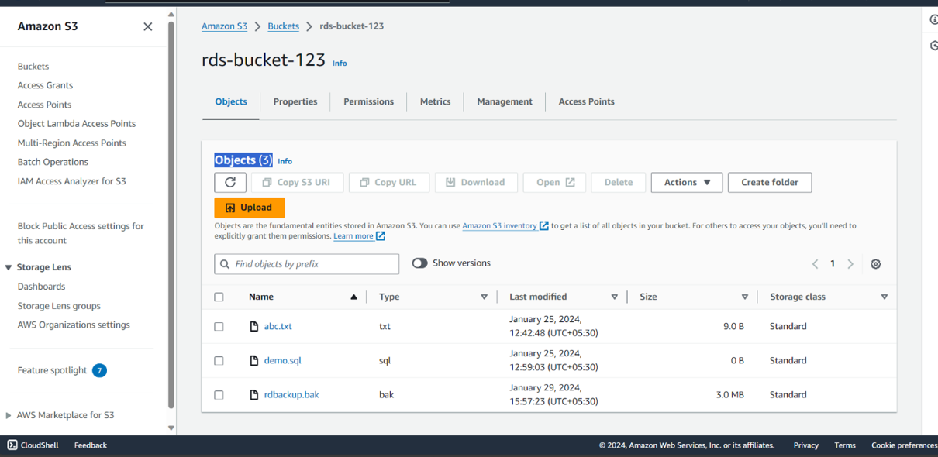
Figure 2-9 Backup Uploaded in S3 Bucket

System Planning

AGILE
Agile methodologies are commonly applied in software development projects, including the development and management of CI/CD pipelines. Here's how you can adapt Agile principles and practices to the CI/CD pipeline development process:

Iterative Development:
  - Break down the development of the CI/CD pipeline into smaller, manageable iterations called sprints. Each sprint focuses on delivering a specific set of features, improvements, or fixes to the pipeline.

User Stories and Backlog:
  - Define user stories that capture the requirements and functionalities of the CI/CD pipeline from the perspective of its users (developers, testers, operations teams, etc.). Prioritize these user stories and maintain a backlog of items to be implemented in future sprints.

Sprint Planning:
  - Conduct sprint planning meetings at the beginning of each sprint to select user stories from the backlog and define the tasks required to implement them. Estimate the effort required for each task and assign them to team members.

Daily Stand-ups:
  - Hold daily stand-up meetings to discuss progress, obstacles, and plans for the day. Team members share updates on their tasks, raise any issues or blockers, and collaborate to resolve them.

Continuous Integration:
  - Embrace the Agile principle of continuous integration by integrating code changes into the mainline repository frequently, preferably multiple times a day. Automate the process of building and testing code changes to ensure that they are integrated smoothly and without errors.

Continuous Deployment:
  - Apply the concept of continuous deployment to automate the deployment of code changes to production-like environments as soon as they pass the required tests.

  - Automate the provisioning and configuration of infrastructure to support rapid.

Feedback and Adaptation:
  - Solicit feedback from developers, testers, and end-users, throughout the development process. Use feedback to iterate on the design and implementation of the CI/CD pipeline, making adjustments as needed to meet evolving requirements and expectations.

Retrospectives:
  - Hold sprint retrospectives at the end of each sprint to reflect on what went well, what could be improved, and what lessons were learned. Identify opportunities for process improvements and take actions to address any issues or concerns raised by the team.

Continuous Improvement:
  - Foster a culture of continuous improvement within the team by encouraging experimentation, innovation, and learning. Regularly review and refine the CI/CD pipeline to incorporate new technologies, best practices, and lessons learned from previous sprints.

Collaboration and Communication:
- Promote collaboration and communication among team members, stakeholders, and other relevant parties involved in the development and operation of the CI/CD pipeline. Foster transparency, trust, and open dialogue to facilitate effective teamwork and decision-making

Advantages od Agile Model:
- Flexibility and Adaptability: Agile methodologies allow teams to respond quickly to changing requirements and market conditions. This flexibility is particularly beneficial in CI/CD pipelines, where rapid iteration and deployment are essential.
- Incremental Delivery: Agile promotes incremental delivery of features and improvements, allowing teams to release valuable updates to the CI/CD pipeline regularly. This approach enables faster time-to-market and continuous improvement of the pipeline.
- Stakeholder Collaboration: Agile encourages collaboration between development teams, operations teams, and other stakeholders involved in the CI/CD pipeline. By

- involving stakeholders throughout the development process, Agile ensures that the pipeline meets their needs and expectations.
- Continuous Feedback: Agile emphasizes the importance of continuous feedback from stakeholders, which helps identify issues early and guide the direction of development.
In the context of CI/CD pipelines, feedback loops enable teams to iterate on the pipeline and improve its performance over time.
- Reduced Risk: Agile methodologies promote early and frequent testing, which helps identify and mitigate risks early in the development process. By delivering smaller, incremental changes, Agile reduces the likelihood of major failures and disruptions in the CI/CD pipeline.
- Improved Quality: Agile promotes continuous testing and integration, leading to higher software quality. By identifying and fixing issues early in the development process, Agile helps prevent defects from propagating through the CI/CD pipeline, resulting in more reliable releases.

Disadvantages of Agile Model:
- Complexity: Agile methodologies can introduce complexity, especially in large-scale CI/CD pipelines with multiple teams and dependencies. Managing dependencies, coordinating releases, and ensuring consistency across teams can become challenging in Agile environments.
- Resource Intensive: Agile requires active participation from team members, stakeholders, and other parties involved in the CI/CD pipeline. This can be resource- intensive, particularly for teams with limited time, budget, or expertise.
- Cultural Shift: Adopting Agile methodologies often requires a cultural shift within organizations, including changes in mindset, practices, and workflows. Resistance to change and lack of buy-in from stakeholders can hinder the successful implementation of Agile in CI/CD pipelines.
- Scope Creep: Agile's focus on flexibility and adaptability can sometimes lead to scope creep, where the scope of the CI/CD pipeline expands beyond the original plan. Without proper controls and prioritization, this can result in delays, budget overruns, and reduced efficiency.
- Documentation and Governance: Agile places less emphasis on documentation and formal governance processes compared to traditional development methodologies.

- While this can improve agility and responsiveness, it may also lead to inconsistencies, lack of traceability, and compliance issues in CI/CD pipelines.

Timeline Chart

ACTIVITY | 18 dec-16 Jan | 17 Jan-19 Feb | 20 Feb-21 March | 22 March-19 April | 20 April-30 May
Requirement Analysis
Designing
Implementation
Testing
Report Generation

Table 3.1 Timeline Chart

Project Development & Testing

CONTINUOUS INTEGRATION & DEVELOPMENT
Continuous Integration (CI) is a software development practice where members of a team integrate their work frequently, usually multiple times a day. Each integration is verified by automated builds and tests, allowing teams to detect problems early. Continuous Integration aims to improve the quality of software, reduce integration issues, and increase the speed of development.
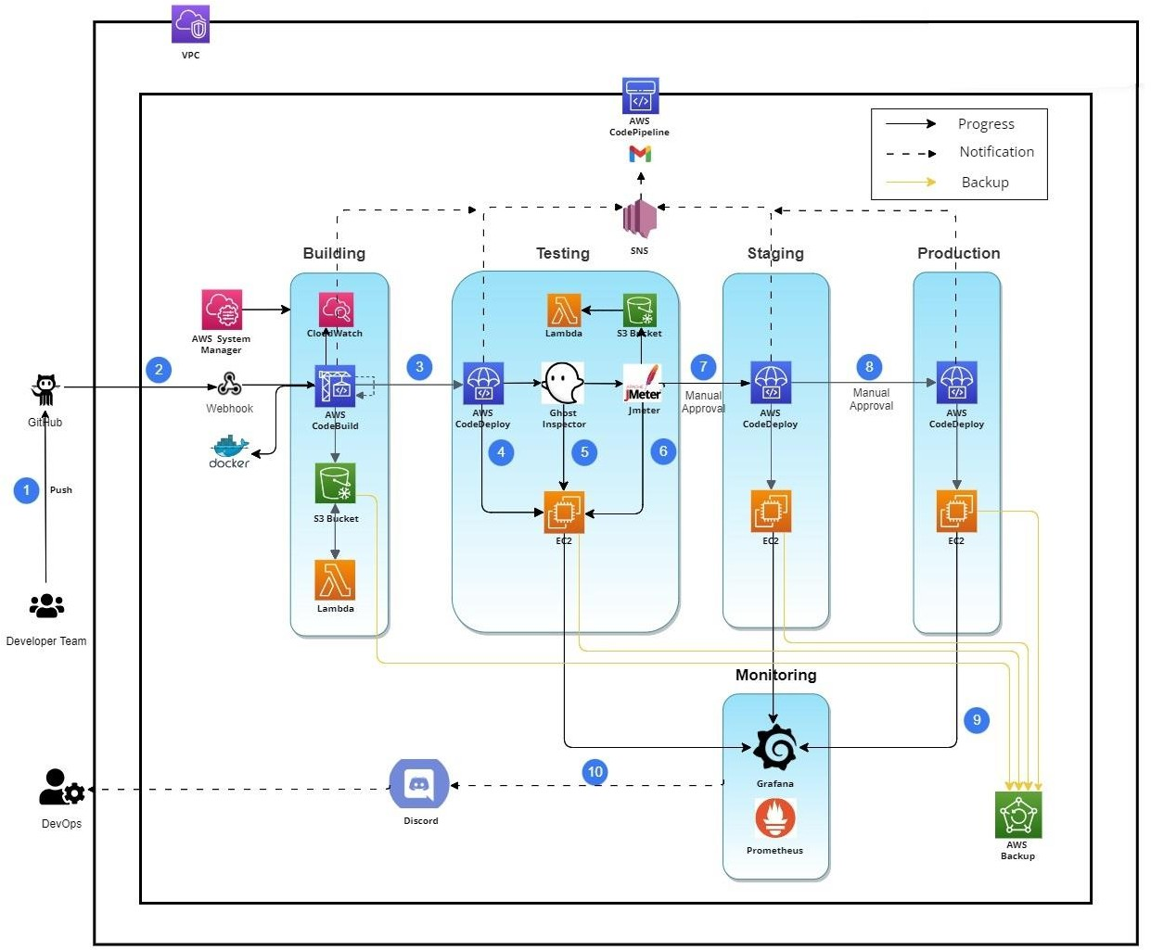
Figure 4-1 CodePipeline Flow Chart

Visual Studio Code
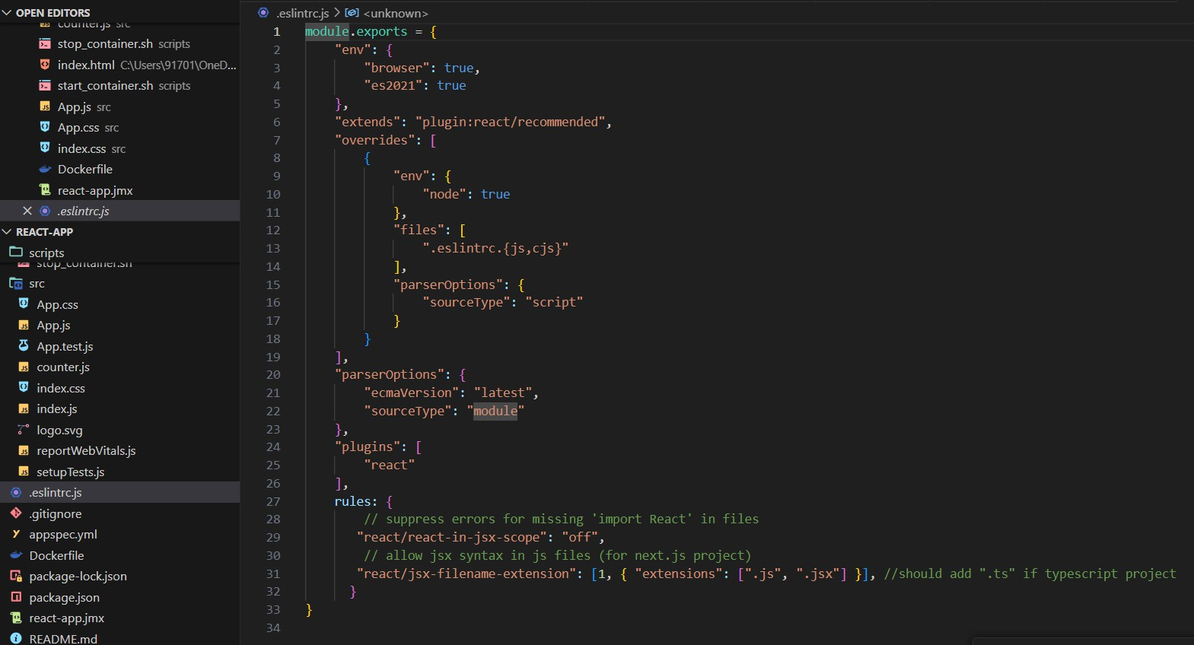
Visual Studio, Microsoft's integrated development environment (IDE), plays a significant role across various stages of the CI/CD pipeline. In the development stage, Visual Studio serves as a robust environment for software creation, offering features for code editing, debugging, and version control. It has been used for developing react website and I have added linting tool named ESlint is a tool for identifying and reporting on patterns found in ECMAScript/JavaScript code, with the goal of making code more consistent and avoiding bugs.
Figure 4-2 Eslint code File

GitHub
GitHub, a pivotal platform for version control and collaborative development, plays a pivotal role across the spectrum of the CI/CD pipeline. In the development phase, GitHub serves as a centralized repository where developers store and manage their codebase using Git.
Its version control features enable developers to track changes, manage branches, and facilitate seamless collaboration among team members. It also have branch protection so developers can not directly push to main branch rather they have to first, take approval from administrator that changes made are valid. Only administrator , is allowed to make changes directly to main

branch. All other developers have to first make new branch and add their respective changes in that branch which is later verified by administrator.
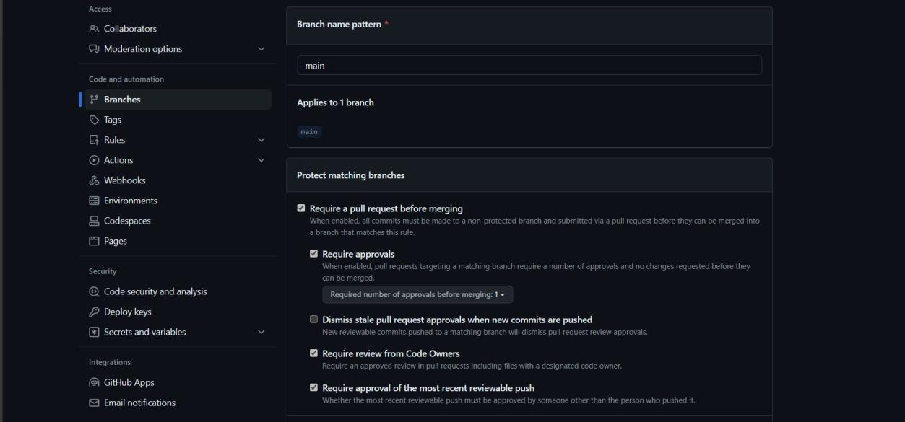
Figure 4-3 Branch Protection

Code Build
AWS CodeBuild is a fully managed continuous integration service that compiles source code, runs tests, and produces software packages that are ready to deploy. It eliminates the need to provision, manage, and scale your own build servers.
Steps to create build project:
- Go to the AWS Management Console and navigate to the CodeBuild service.
- Click on "Create build project".
- Enter a name for your project and optionally provide a description.
- Choose the source provider (e.g., AWS CodeCommit, GitHub, Bitbucket).
- Configure the source settings (e.g., repository URL, branch).
- Choose the environment for your build (e.g., operating system, runtime, compute type).
- Configure build specifications: You can either provide a buildspec file in your source repository or define build commands directly in the console.
- Choose the service role for CodeBuild: Either create a new service role or select an

- existing one. This role should have the necessary permissions to access AWS resources required during the build process.
- Review your configuration and click "Create build project".
The code build will be triggered in pipeline after running successfully source in pipeline . It will build a EC2 instance according to predefined configuration to test the project. The buildspec file will be run and it will firstly install npm on machine , the react app will be tested by command npm run build.
After successfully testing , the docker is installed and the docker image is created and pushed to docker repository. The necessary information for login and pushing image is stored in AWS system manager , it is accessed using parameter store in buildspec file . Then after successful pushing image in repository , artifacts are stored in S3 bucket. Lambda function will delete old artifacts file when new is added.
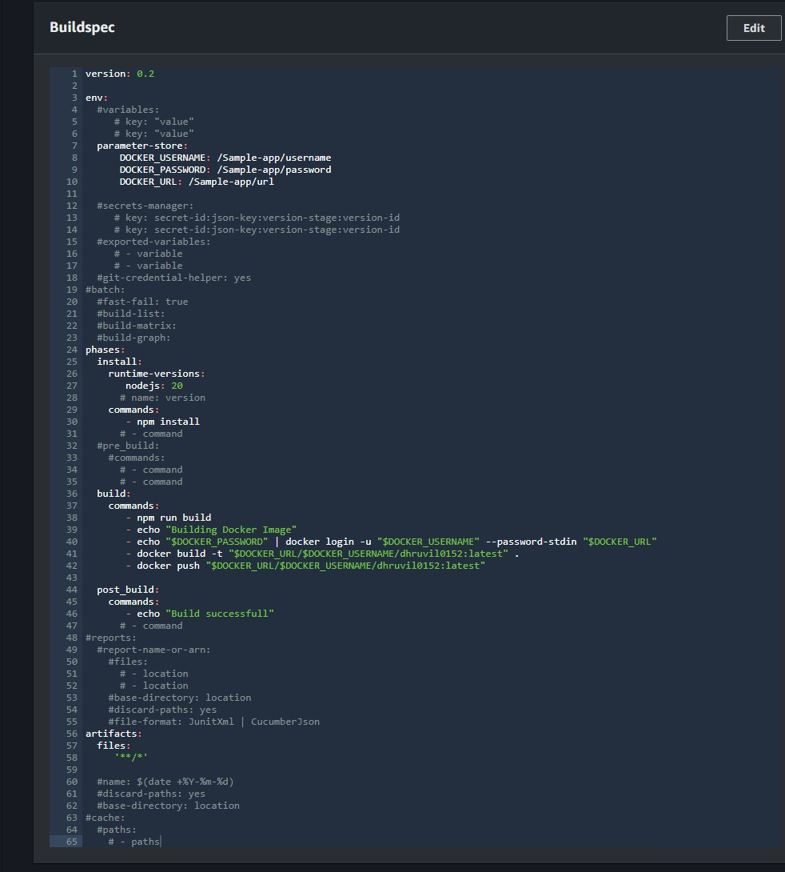
Figure 4-4 Buildspec.yml file

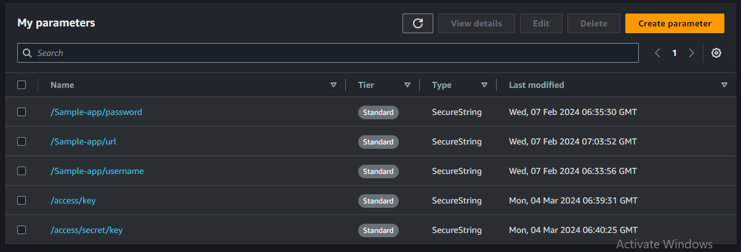
Figure 4-5 AWS System Manager

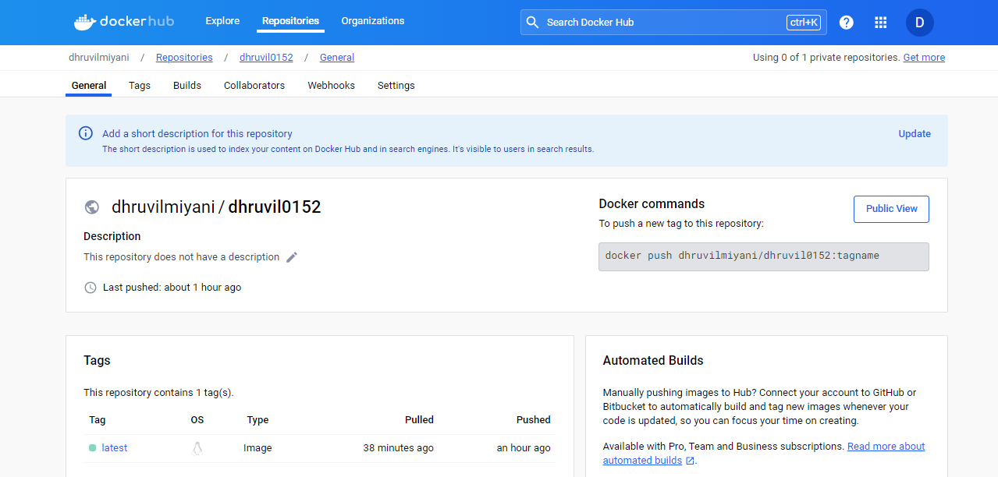

Figure 4-6 Docker Repository

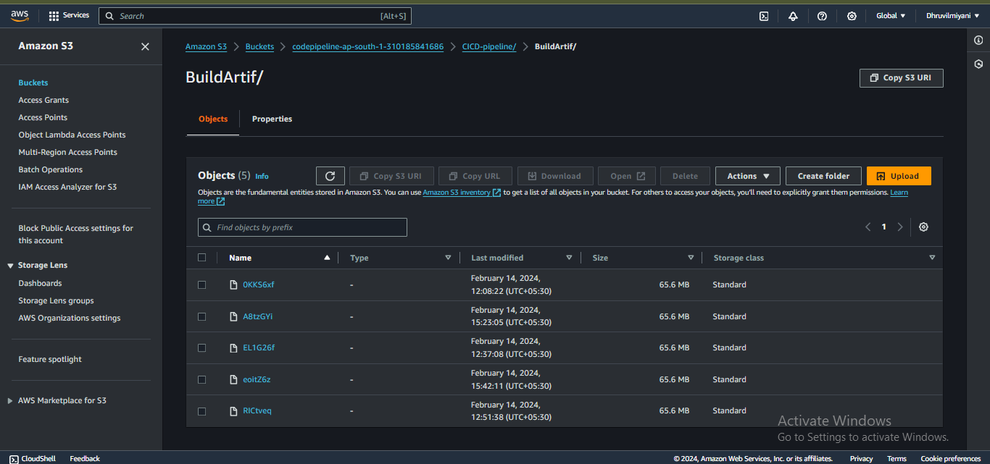
Figure 4-7 Build Artifacts

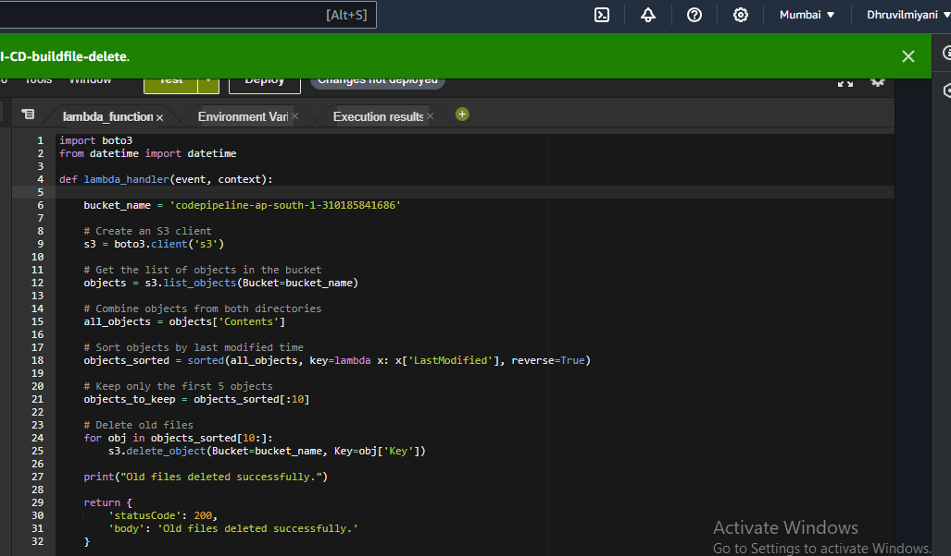

Figure 4-8 Lambda Function Code

CONTINUOUS TESTING

UI-TESTING
UI testing, also known as User Interface testing or GUI testing, is a type of software testing that focuses on verifying the graphical user interface (GUI) of an application. The purpose of UI testing is to ensure that the application's interface behaves as expected and meets the specified requirements, providing a smooth and user-friendly experience for the end-users.

Ghost Inspector
Ghost Inspector is a cloud-based automated testing tool designed specifically for website and web application testing. It provides users with a comprehensive platform to create, manage, and execute automated tests to validate the functionality, performance, and appearance of web pages and applications. With Ghost Inspector, users can record their interactions with web pages using a browser extension, capturing actions such as clicks, form submissions, and navigation. These interactions are then converted into test steps that can be replayed as automated tests. The tool supports various types of tests, including functional tests, regression tests, and visual regression tests, allowing users to ensure the integrity of their web applications

across different browsers and environments. Additionally, Ghost Inspector offers features such as scheduled testing, integration with CI/CD pipelines, and detailed reporting and analysis, enabling teams to incorporate automated testing seamlessly into their development workflows. Overall, Ghost Inspector streamlines the process of automated testing for web applications, empowering teams to deliver high-quality software with confidence and efficiency.
Steps to configure Ghost Inspector:

Sign Up for an Account:
          - Visit the Ghost Inspector website and sign up for an account. You can choose from different pricing plans based on your testing needs. Once signed up, log in to your account.

Create a New Test Suite:
          - After logging in, navigate to the dashboard and click on "New Suite" to create a new test suite. A test suite is a collection of related tests that you want to run together, such as tests for a specific web application or feature.

Create a New Test:
          - Within the test suite, click on "New Test" to create a new test. Give your test a descriptive name and specify the URL of the web page or application you want to test.

Record Test Steps:
          - Use the Ghost Inspector browser extension (available for Chrome and Firefox) to record your interactions with the web page. Perform the actions you want to test, such as clicking buttons, filling out forms, and navigating between pages. The extension will capture your actions as test steps.

Edit Test Steps :
          - After recording your test steps, you can edit them as needed. You can rearrange steps, add assertions to verify expected outcomes, and customize settings such as timeouts and delays.

Save and Run Test:
          - Once you're satisfied with your test, save it and run it to verify that it executes successfully. Ghost Inspector will open a browser window and perform the recorded actions on the specified URL. You can monitor the test execution in real-time and view the results afterward.

Review Test Results:
          - After the test completes, review the results to see if any steps failed. Ghost Inspector provides detailed logs, screenshots, and error messages to help you diagnose issues

Integrate with CI/CD Pipeline:
          - To incorporate Ghost Inspector into your CI/CD pipeline, you can use the Ghost Inspector API or integrations with code pipeline service. Set up automated tests to run as part of your build and deployment process for continuous validation.

Manage and Maintain Tests:
          - As your application evolves, regularly update and maintain your tests to ensure they remain accurate and effective. Modify tests as needed to accommodate changes in the application's functionality or user interface.
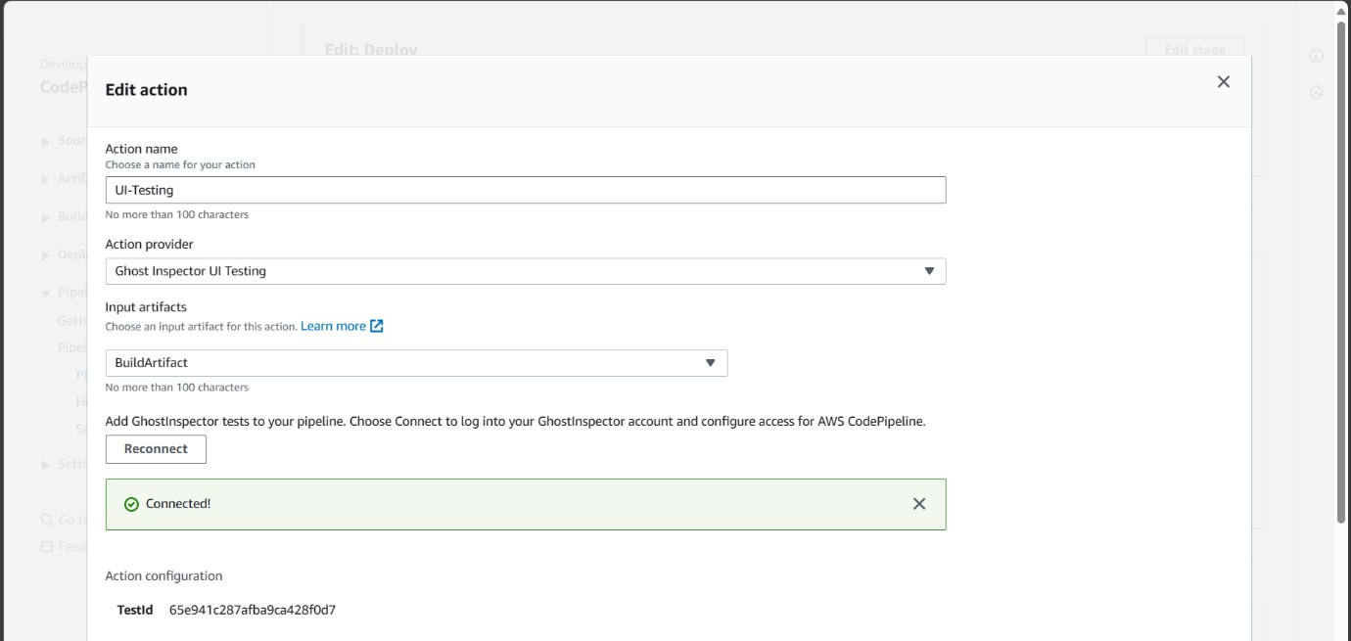

Figure 4-9 Pipeline Connection with Ghost Inspector

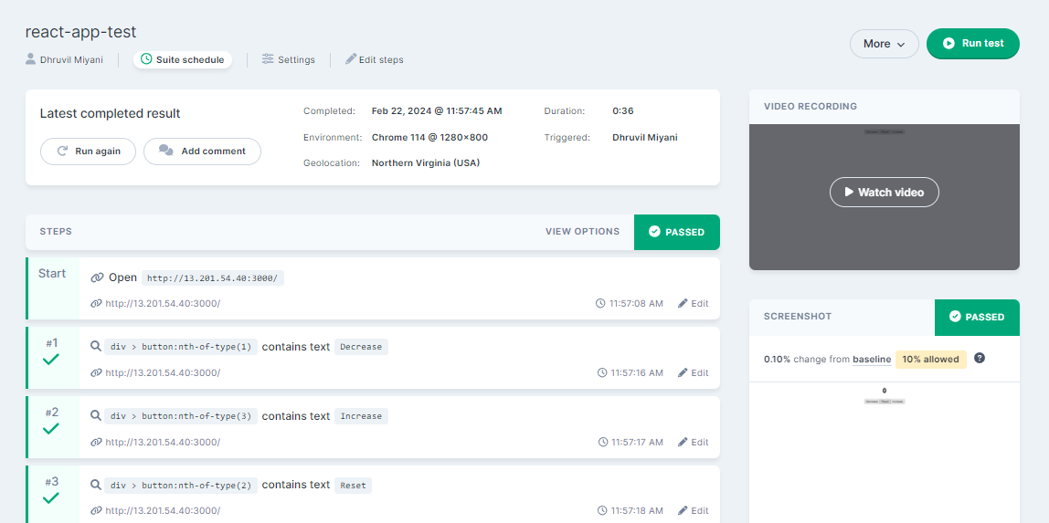

Figure 4-10 Ghost Inspector Test Site

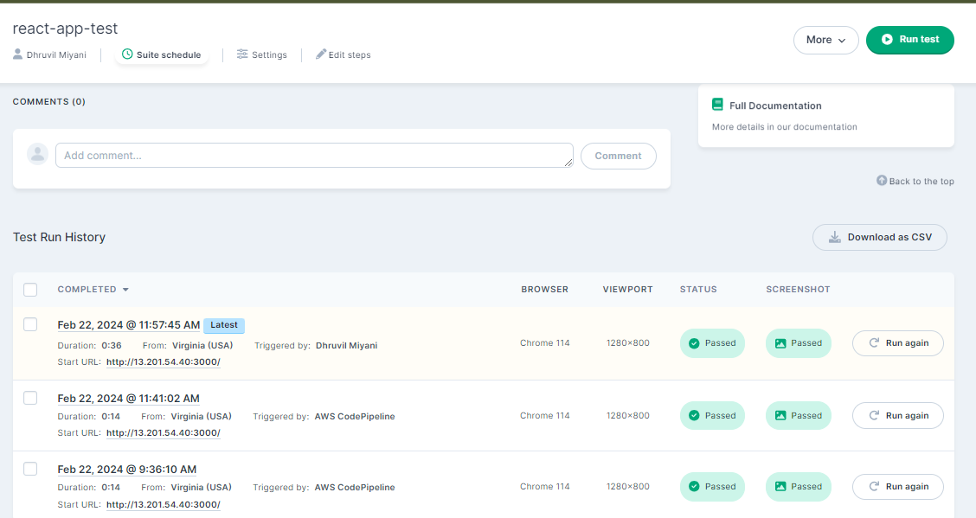

Figure 4-11 Ghost Inspector Test Result

Load Testing
A load test of a website is a type of performance testing that evaluates how well a web application or website performs under a specific load or traffic volume. The purpose of load testing is to determine the application's capacity to handle concurrent users and transactions without experiencing performance degradation or downtime.
During a load test, simulated users (often referred to as virtual users or VUs) interact with the website by performing various actions, such as browsing pages, submitting forms, and downloading files. The load testing tool generates a predefined number of concurrent VUs and distributes them across the website to simulate realistic user behaviour.

JMeter
Apache JMeter is an open-source load testing tool developed by the Apache Software Foundation. It is widely used for performance testing of web applications, APIs, and other services. JMeter is Java-based and provides a user-friendly graphical interface for creating and running load tests.

Download and Install JMeter:
          - Go to the Apache JMeter website (https://jmeter.apache.org/) and download the latest version of JMeter.
          - Extract the downloaded archive to a directory on your computer.
          - JMeter does not require installation; you can run it directly from the extracted folder.

Start JMeter:
          - Navigate to the bin directory within the extracted JMeter folder.
          - Run the JMeter executable file (jmeter.bat for Windows or jmeter.sh for Unix/Linux) to start the JMeter GUI.

Create a Test Plan:
          - In the JMeter GUI, create a new test plan by selecting "File" > "New".
          - Add elements to your test plan such as Thread Group, HTTP Request Sampler, and Listeners.
          - The Thread Group defines the number of virtual users, ramp-up period, and test duration.

          - The HTTP Request Sampler represents the web request to be sent to the server.

Configure Thread Group:
          - Right-click on the Test Plan and select "Add" > "Threads" > "Thread Group".Configure the Thread Group properties such as the number of threads (virtual users), ramp-up period (time to start all threads), and loop count (number of iterations).

Add HTTP Request Sampler:
          - Right-click on the Thread Group and select "Add" > "Sampler" > "HTTP Request".
          - Configure the HTTP Request Sampler properties such as the server name or IP address, port number, protocol (HTTP or HTTPS), and path.

JMX File:
          - Save the file having .jmx extension and copy it into project.
Load Test is carried out in code build service where the JMeter is firstly installed on EC2 Instance and run the .jmx file using JMeter command . The result are generated in csv file and dashboard which are uploaded in S3 bucket.
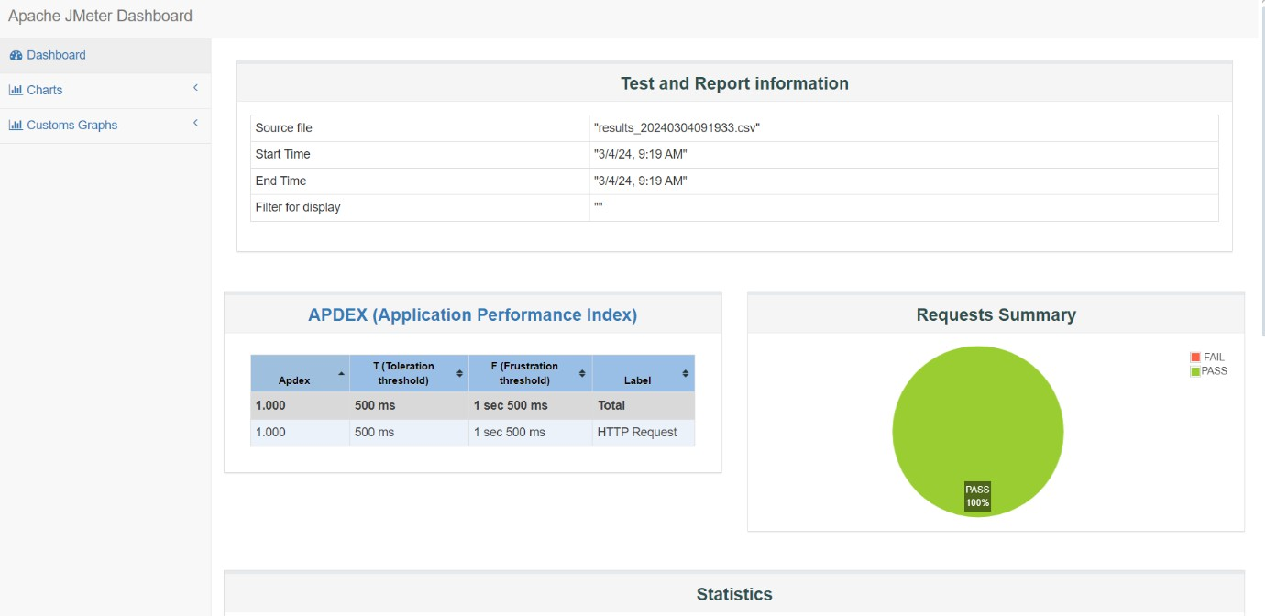
Figure 4-12 Dashboard of Result Generated from JMeter Test

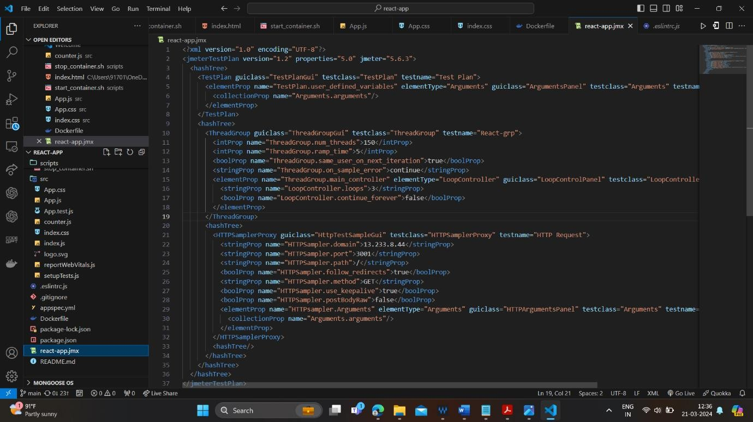

Figure 4-13 JMeter Config File
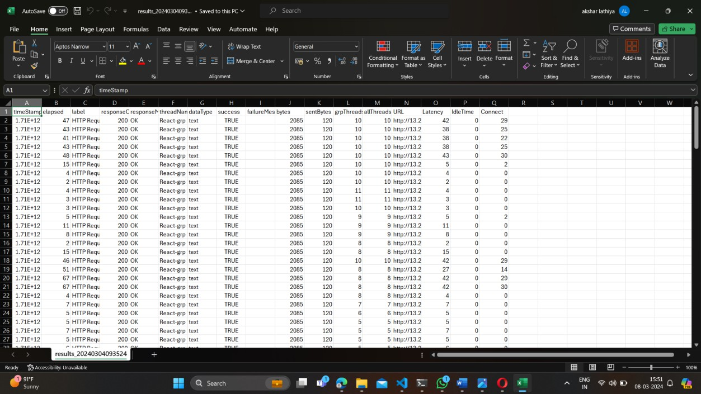
Figure 4-14 CSV File Output


Figure 4-15 Lambda Function Code For S3 File Deletion

dEPLOYMENT aND MONITORING

CONTINUOUS DEPLOYMENT
Continuous Deployment (CD) is a progressive software development approach where code changes are seamlessly and automatically deployed to production environments without the need for manual intervention, provided they pass a battery of automated tests and validation processes. This methodology extends the principles of Continuous Integration (CI), where code changes are integrated frequently into a shared repository and verified through automated builds and tests.
In the Continuous Deployment workflow, developers commit their code changes to a version control system, like Git, where these changes are regularly merged into a primary branch such as 'master' or 'mainline'. Upon each commit or merge, an automated build process is initiated. This build process compiles the code, executes unit tests, and conducts other automated checks to ensure the integrity of the changes and to guard against introducing regressions.

Code Deploy
AWS CodeDeploy is a fully managed deployment service provided by Amazon Web Services (AWS) that automates the process of deploying applications to a variety of compute environments including Amazon EC2 instances, AWS Lambda functions, and instances running on-premises. It facilitates continuous deployment by automating code deployments and enabling you to release new features and updates rapidly and reliably.
- Create an IAM Service Role:
  - Before you begin, ensure you have an IAM service role with the necessary permissions for AWS CodeDeploy. This role allows CodeDeploy to access AWS resources during the deployment process.
  - You can create a new IAM service role specifically for CodeDeploy or use an existing one.
  - Ensure the IAM role has permissions for CodeDeploy actions, access to the S3 bucket where application revisions are stored, and permissions to interact with the EC2 instances or other compute resources targeted for deployment.

- Prepare Your Application:
  - Package your application code and any necessary deployment artifacts into an archive format (e.g., .zip, .tar.gz).
  - Upload the application archive to an S3 bucket. Ensure that the S3 bucket is accessible to AWS CodeDeploy and that the IAM service role has permissions to access the bucket..

- Create an Application:
  - Navigate to the AWS CodeDeploy console.
  - Click on "Create application".
  - Enter a name and optionally a description for your application.

- Create Deployment Groups:
  - After creating an application, create one or more deployment groups within the application.
  - Deployment groups define the target environment and specify the instances or Amazon ECS services where the application will be deployed.
  - Define deployment group settings such as deployment type, deployment configuration, load balancer settings (if applicable), and auto-scaling group settings (if deploying to EC2 instances).

- Create a Deployment Configuration (Optional):
  - You can create custom deployment configurations to specify the deployment settings, such as the deployment strategy, minimum healthy hosts, and deployment alarm thresholds.
  - If you don't create a custom deployment configuration, AWS CodeDeploy uses the default deployment configuration.

- Create a Deployment:
  - Once your application, deployment groups, and optionally deployment configuration are set up, you can create a deployment.
  - Select the application and deployment group, choose the revision (application

version) stored in the S3 bucket, and specify any deployment configuration settings.
  - Start the deployment process.
- Monitor Deployment Progress:
  - Monitor the deployment progress in the AWS CodeDeploy console.
  - View deployment logs and details to track the status of each deployment step and any errors encountered during deployment.
- Verify and Test Deployment:
  - After the deployment is complete, verify that the application is successfully deployed to the target environment.

Perform any necessary testing to ensure that the application functions as expected in the deployed environment.

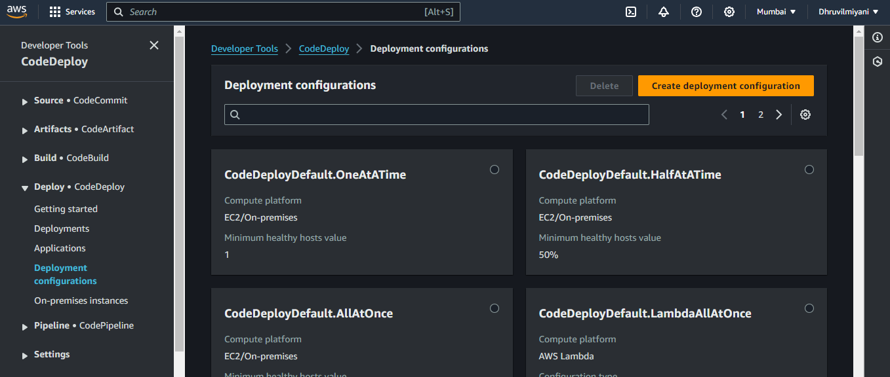

Figure 5-1 Deployment Configuration

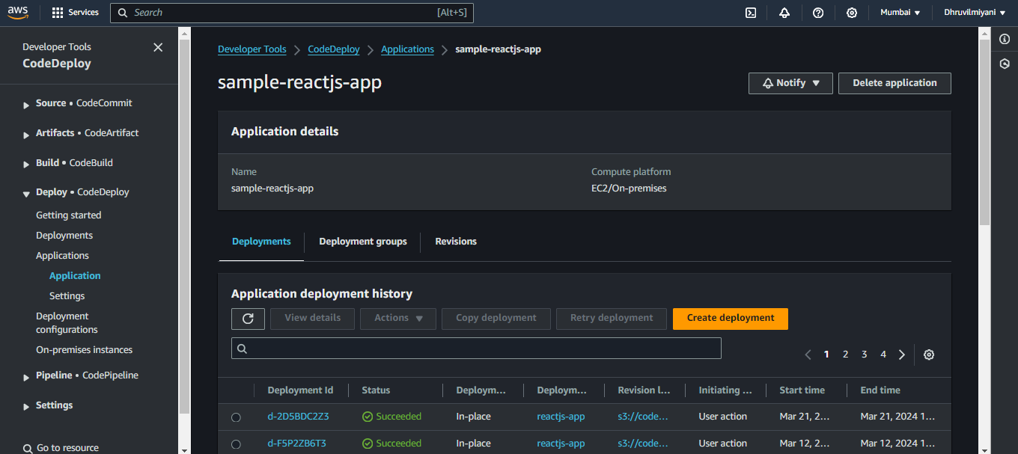
Figure 5-2 Deployment Application

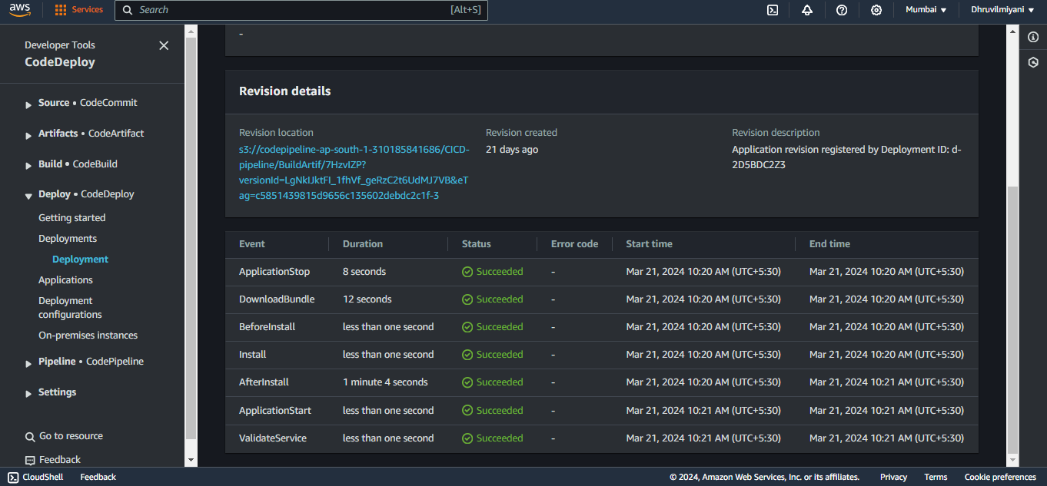
Figure 5-3 Lifecycle Events of Code Deployment

CODE DEPLOYMENT ON EC2 INSTANCE
After configuring code deploy service , the code deploy-agent should be installed in EC2 instance so the deployment can be successfully work.
- Sign in to the instance.
- Enter the following commands, one after the other:

  - sudo apt update
  - sudo apt install ruby-full
  - sudo apt install wget
- Enter the following command:
  - wget https://bucket-name.s3.region-identifier.amazonaws.com/latest/install
bucket-name is the name of the Amazon S3 bucket that contains the CodeDeploy
Resource Kit files for your region, and region-identifier is the identifier for your region.
For example:
https://aws-codedeploy-us-east-2.s3.us-east-2.amazonaws.com/latest/install
- Enter the following command:

chmod +x ./install
- To install the latest version of the CodeDeploy agent on any supported version of Ubuntu Server except 20.04:

sudo ./install auto
- Commands to check status of code deploy-agent:

sudo systemctl status codedeploy-agent
- If the status is no codedeploy-agent found then run following command:

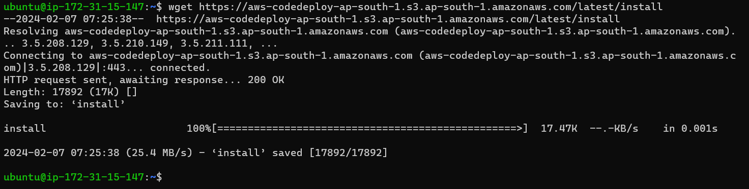
sudo systemctl start codedeploy-agent
Figure 5-4 Command to get S3 Bucket

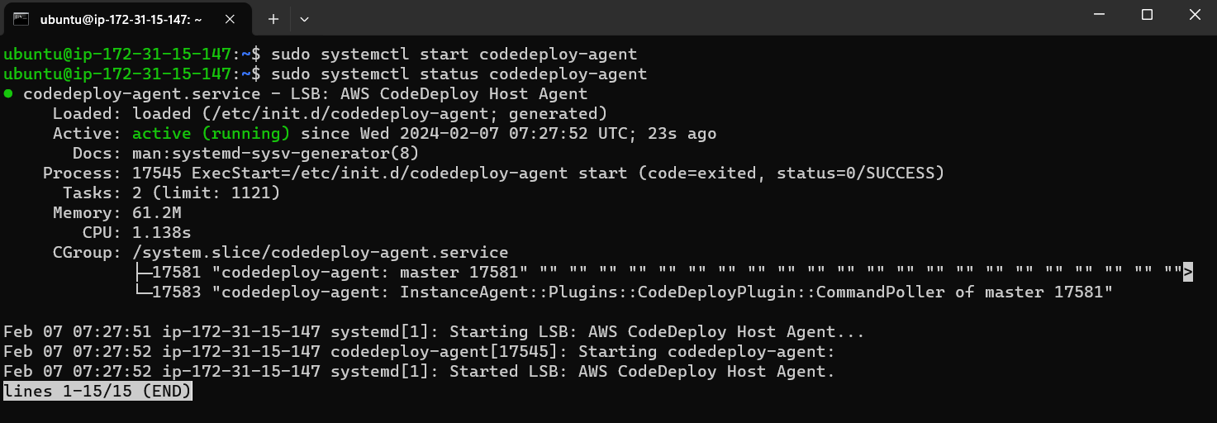
Figure 5-5 Status of Code-Agent

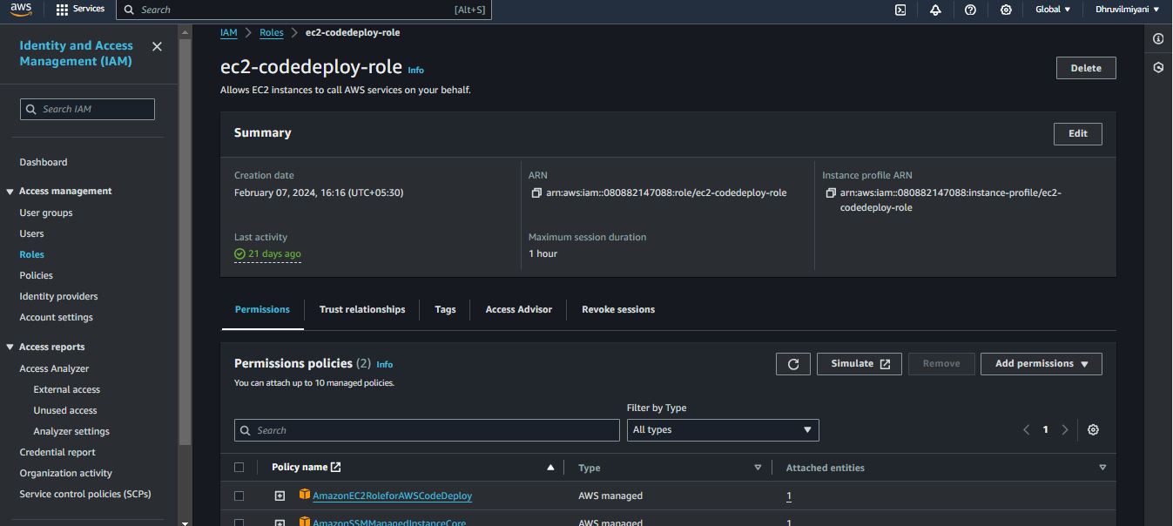

Figure 5-6 IAM Role Of EC2 Codedeploy
After adding IAM role to EC2 instance , restart the code deploy-agent using sudo systemctl restart codedeploy-agent.

CONTINUOUS FEEDBACK
Continuous feedback is an essential aspect of a CI/CD pipeline, providing valuable insights and information at every stage of the software development and deployment process. It involves collecting data, analysing metrics, and providing feedback to developers, testers, and stakeholders to improve the quality, efficiency, and reliability of the pipeline.

SNS(SIMPLE NOTIFICATION SERVICE)
Amazon Simple Notification Service, is a fully managed messaging service provided by Amazon Web Services. It enables you to send notifications or messages to a large number of subscribers or endpoints, including email, SMS, HTTP/S, AWS Lambda, SQS, mobile devices, and more.
- Create an SNS Topic:
  - Go to the AWS Management Console and navigate to the SNS service.
  - Click on "Create topic".
  - Enter a name and an optional display name for your topic.
  - Click on "Create topic" to create the SNS topic.
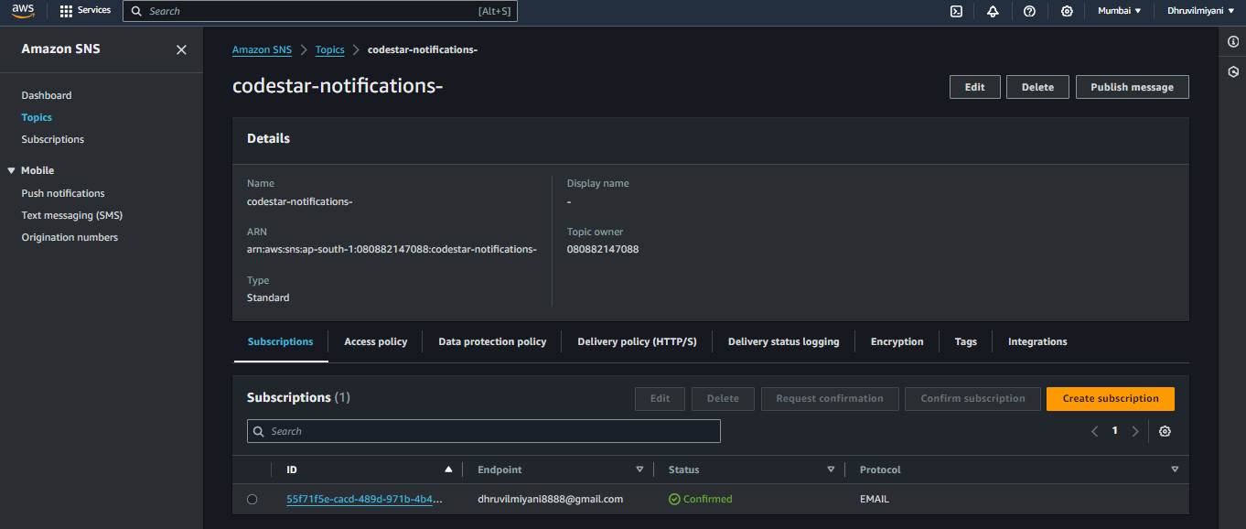
Figure 5-7 SNS
- Create Subscriptions:
  - Once the topic is created, you can create subscriptions to specify where you want to send messages published to the topic.
  - Click on the topic you created, then click on "Create subscription".
  - Choose the protocol for the subscription (e.g., Email, SMS, HTTP, HTTPS, Lambda, SQS).
  - Depending on the chosen protocol, provide the required endpoint information (e.g., email address, phone number, URL, Lambda function ARN, SQS queue ARN).
  - Confirm the subscription request (e.g., by clicking on a confirmation link sent to an email address).

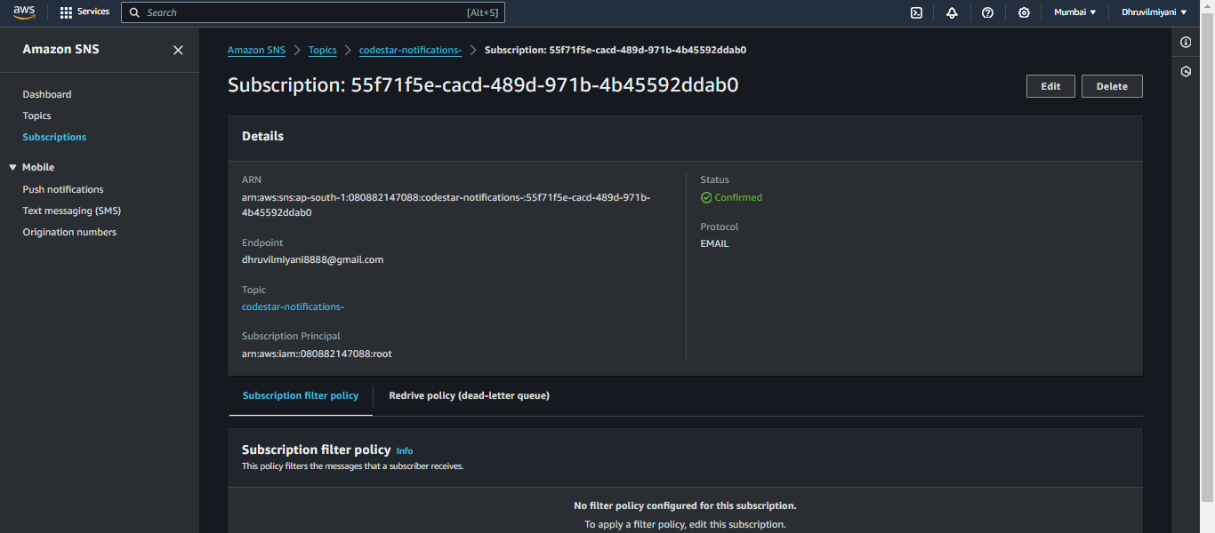
Figure 5-8 Subscription Of SNS
- Publish Messages to the Topic:
  - After creating the topic and subscriptions, you can publish messages to the topic.
  - Click on the topic, then click on "Publish message".
  - Enter the message subject and message body.
  - Optionally, you can add message attributes to provide additional metadata.
  - Click on "Publish message" to send the message to all subscribed endpoints.
- Monitor and Manage SNS Topics:
  - Monitor the activity and performance of your SNS topics using CloudWatch metrics and alarms.
  - Use the SNS console to manage topics, subscriptions, access policies, and other configurations.

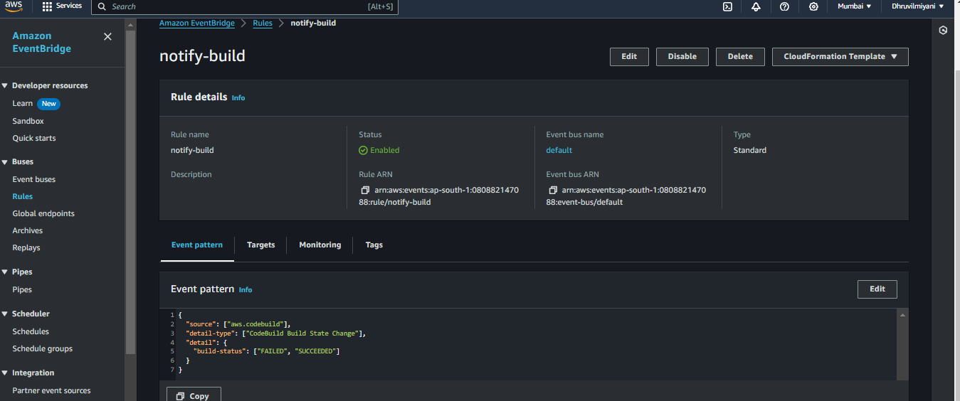
Figure 5-9 Code Deploy Notification Rule
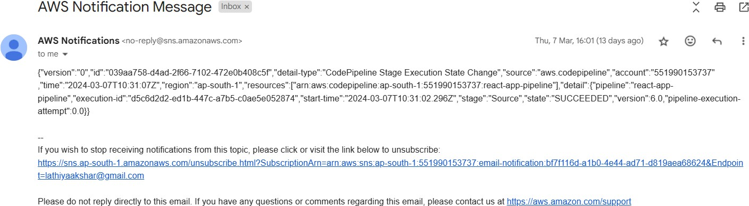

Figure 5-10 Email Notification of Code Pipeline

Discord
Discord is a popular communication platform primarily used by group of people but has expanded to encompass various communities and groups beyond chatting. It provides a combination of text, voice, and video chat features, along with robust community-building tools.
Discord is used to send the notification of CPU usage alarm of Grafana, if the threshold value hits the maximum of its value then it will send the notification in discord. Grafana and discord are connected with webhook.
- Open Discord and navigate to the channel where you want to receive notifications.
- Click on the gear icon next to the channel name and select "Integrations".
- Click on "Create Webhook", then provide a name for your webhook and optionally customize the avatar.
- Copy the webhook URL generated by Discord. This URL will be used to send messages to the channel.
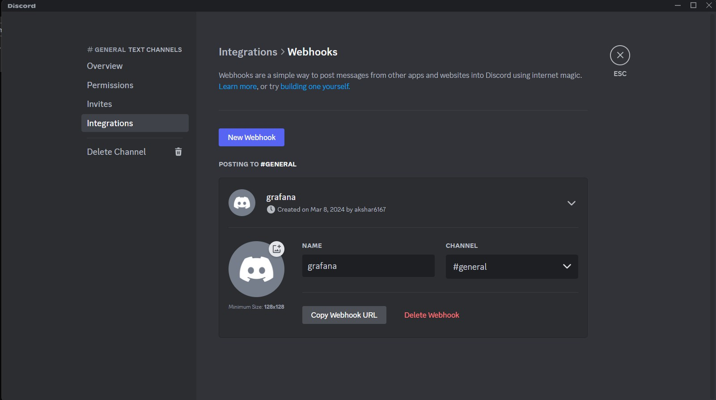
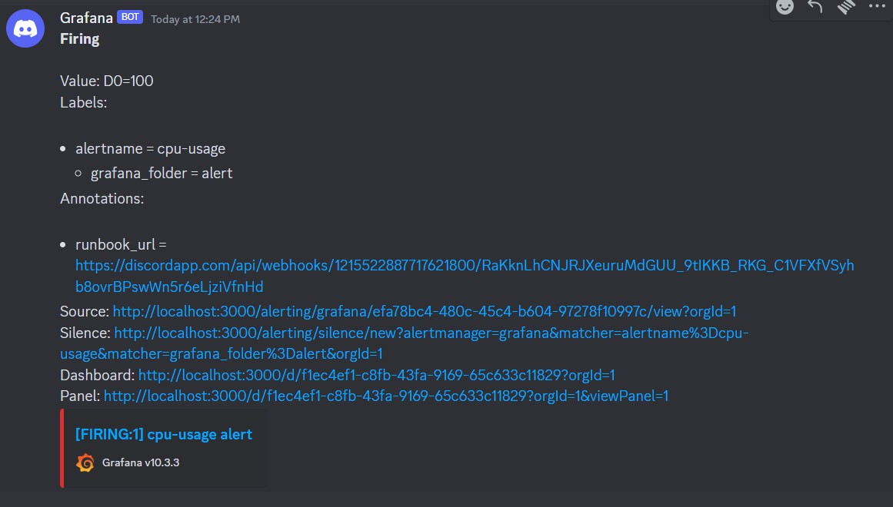

Figure 5-11 Discord Webhook
Figure 5-12 CPU Alert Message
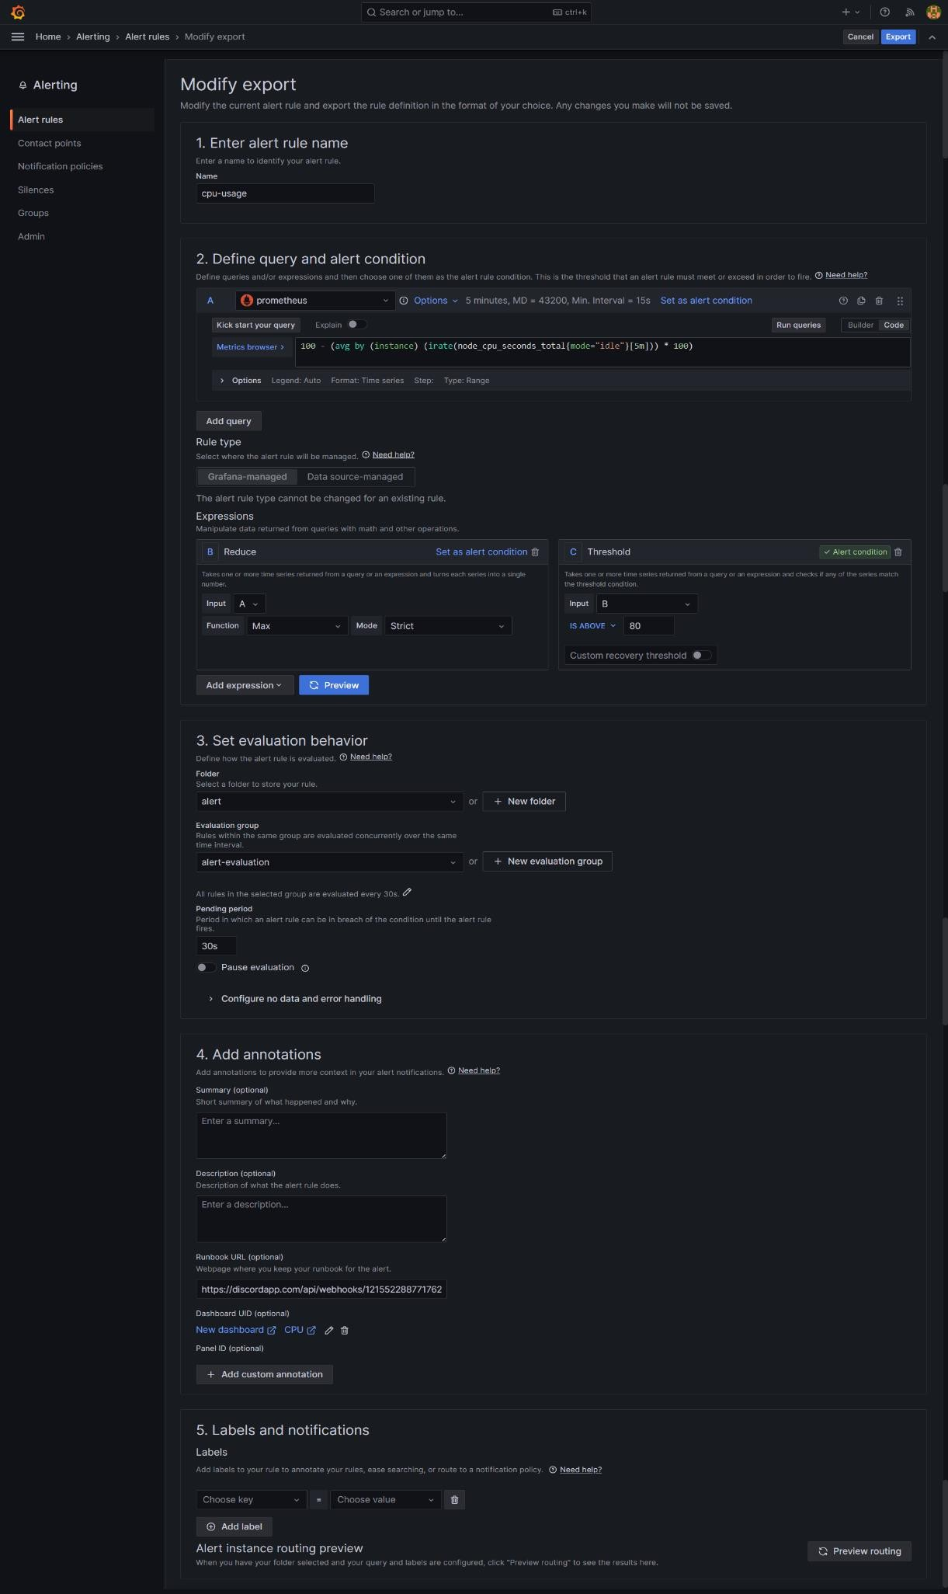
Figure 5-13 Grafana webhook config

COTINUOUS MONITORING
Monitoring in a pipeline context typically refers to the process of observing and tracking various aspects of data, processes, and performance as they flow through a system. In the context of software development or data processing, a pipeline is a series of connected stages or steps where data is processed sequentially. Monitoring these pipelines is crucial for ensuring their efficiency, reliability, and effectiveness.

GRAFANA
Grafana is an open-source analytics and monitoring platform primarily focused on visualizing time-series data. It allows users to create, explore, and share dashboards containing graphs, charts, and other visualizations of their data. Grafana is highly flexible and supports a wide range of data sources, making it popular for monitoring and observability use cases in various domains, including IT infrastructure, application performance monitoring, IoT, and more.
Steps to configure Grafana in EC2 instance:

Launch an EC2 Instance:
  - Sign in to the AWS Management Console.
  - Navigate to the EC2 dashboard.
  - Launch a new EC2 instance, choosing an appropriate Amazon Machine Image (AMI) (e.g., Amazon Linux, Ubuntu, etc.).
  - Configure security groups to allow inbound traffic on the Grafana port (default is TCP port 3000).

Connect to the EC2 Instance:
  - Once the instance is launched, connect to it via SSH using a tool like PuTTY (for Windows) or SSH (for Linux/Mac).
  - Use the key pair associated with the EC2 instance for authentication.

Install Grafana:
  - sudo apt install grafana

Start Grafana Service:
  - sudo systemctl start grafana-server
  - sudo systemctl enable grafana-server

Access Grafana Web Interface:
  - Open a web browser and navigate to the public IP address or DNS name of your EC2 instance, appending :3000 to the address (Grafana's default port).
  - You should see the Grafana login page.

Log in and Configure Grafana:
  - Log in using the default credentials (username: admin, password: admin).
  - Follow the prompts to change the default password.
  - Optionally, configure Grafana data sources and dashboards based on your requirements. You can add data sources like Prometheus, InfluxDB, etc., from the Grafana web interface.

Monitor and Maintain:
  - Monitor the EC2 instance and Grafana service to ensure they are running smoothly.
  - Regularly update Grafana and the underlying operating system to patch security vulnerabilities and access new features.
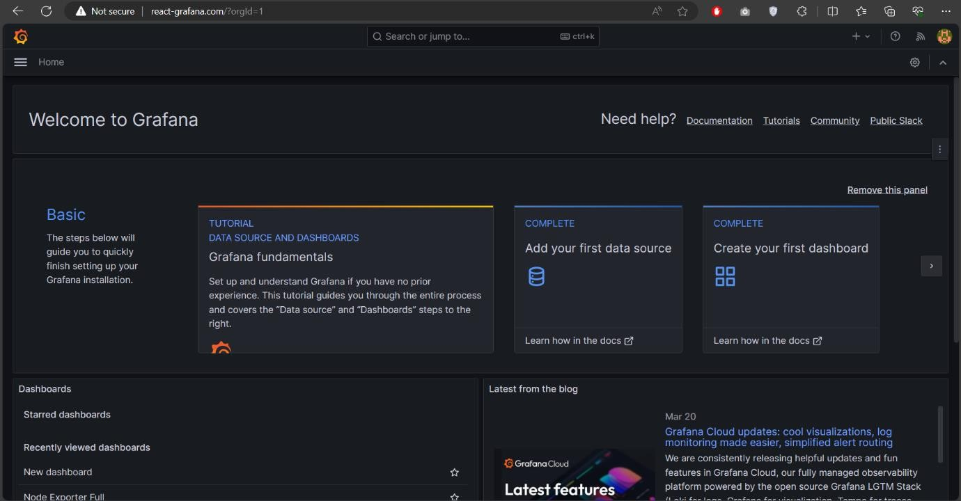
Figure 5-14 Grafana on 3000 Port on Instance

PROMETHEUS
Prometheus is an open-source monitoring and alerting toolkit widely utilized in modern IT environments, particularly within cloud-native and containerized applications. Developed originally by SoundCloud, Prometheus is renowned for its robust capabilities in collecting, storing, querying, and visualizing metrics. Its flexible data model employs labels, enabling multidimensional analysis crucial for efficient querying and insightful analysis. Using a pull- based approach, Prometheus scrapes metrics from HTTP endpoints at regular intervals, ensuring flexibility and adaptability to dynamic environments.
Central to its functionality is PromQL, a powerful query language enabling users to manipulate and retrieve metrics with precision. With its integrated time-series database optimized for high write throughput and efficient querying, Prometheus excels in historical trend analysis and anomaly detection. Its support for various service discovery mechanisms, including Kubernetes integration and cloud service providers, simplifies monitoring setup and maintenance. Additionally, Prometheus offers built-in alerting capabilities and seamless integration with Alertmanager for effective alert routing and management. Its scalability, federation support, and extensive integration ecosystem make Prometheus a cornerstone in the toolkit of DevOps teams and system administrators, facilitating reliable and comprehensive monitoring solutions across diverse infrastructure landscapes.
Prometheus collects metrics from various sources using exporters. Exporters are programs that produce metrics in a format that Prometheus can scrape. There are many pre-built exporters for popular services and applications.
While Prometheus has basic graphing capabilities, it is often used in conjunction with Grafana, a popular open-source platform for monitoring and observability. Grafana provides advanced visualization options and dashboards for Prometheus data.
Prometheus is connected with grafana and it is also run on port 9090 of instance. Grafana will show the graphs on the basis of data collected by Prometheus.
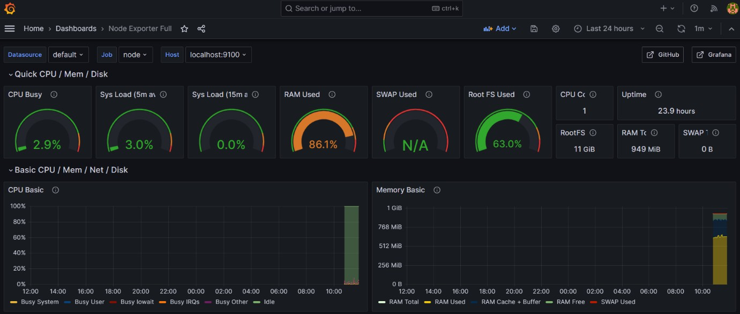
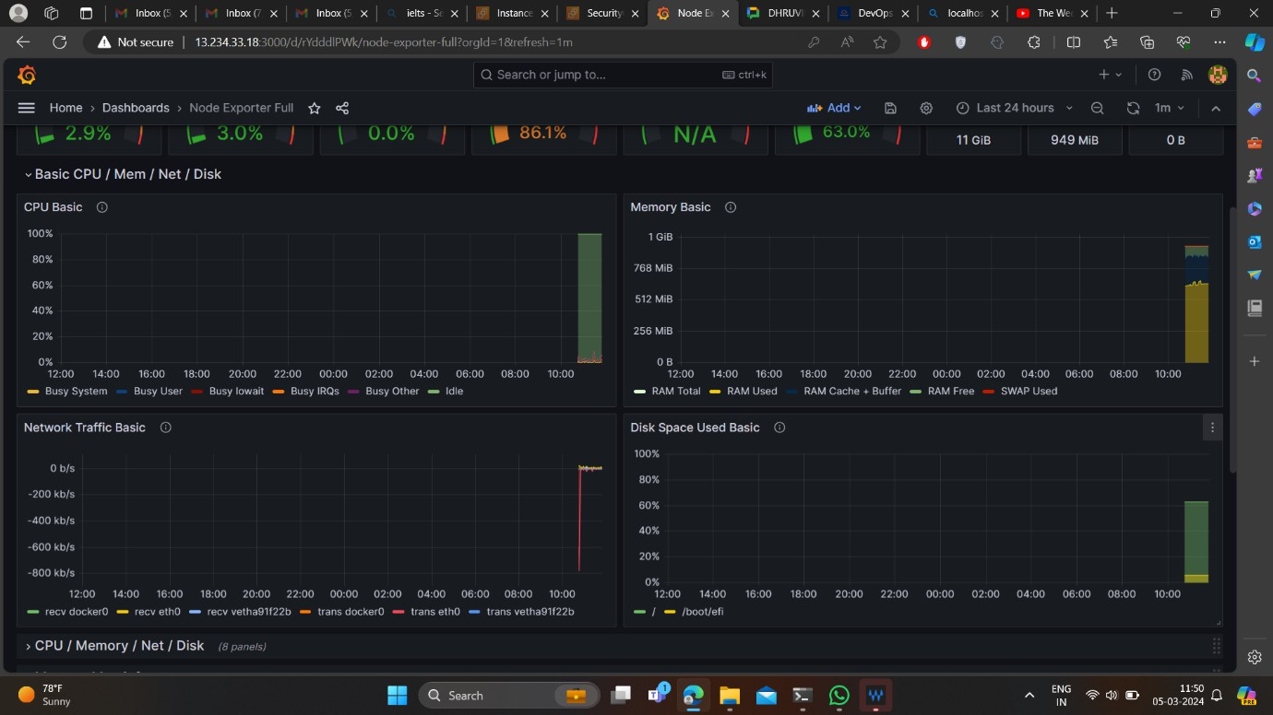

Figure 5-15 Grafana Dashboard

Figure 5-16 Grafana Dashboard
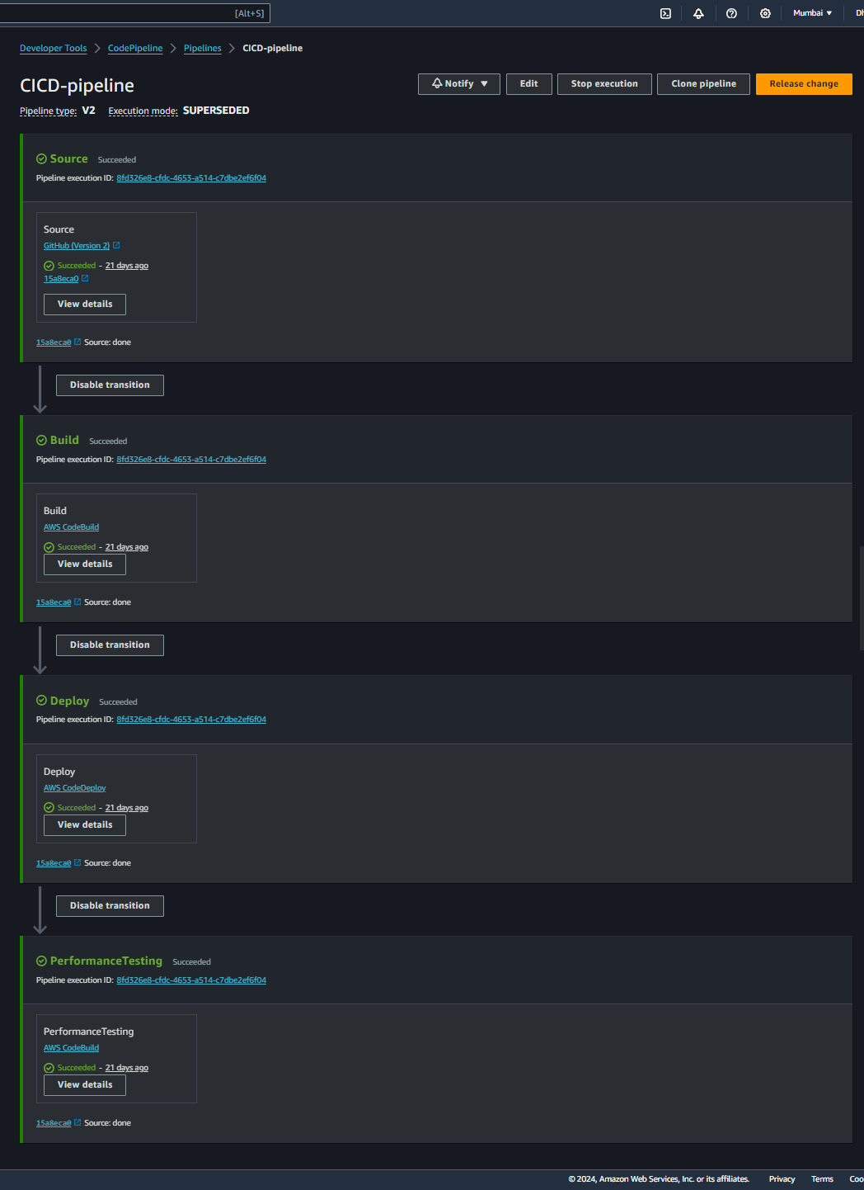
Figure 5-17 CI/CD Pipeline

Conclusion and Future Scope

CONCLUSION
In conclusion, the CI/CD pipeline project has been a resounding success, revolutionizing our software development and deployment processes. Through the implementation of robust CI/CD pipelines, we have achieved significant improvements in efficiency, reliability, and collaboration within our development teams.
The adoption of CI/CD practices has enabled us to automate key aspects of our software delivery lifecycle, from code integration to deployment, leading to faster feedback cycles and quicker time-to-market for our applications. By automating repetitive tasks such as testing and deployment, we have freed up valuable time for our developers to focus on innovation and delivering value to our customers.
Furthermore, the introduction of CI/CD pipelines has enhanced the overall quality of our software products. Continuous integration ensures that code changes are integrated and tested frequently, reducing the likelihood of integration issues and catching bugs early in the development process. Meanwhile, continuous deployment enables us to deploy code changes to production environments with confidence, knowing that they have been thoroughly tested and validated.
Looking ahead, we recognize that the journey towards CI/CD maturity is ongoing. We must continue to refine and optimize our pipelines, incorporating feedback and lessons learned to drive continuous improvement. Additionally, we must remain adaptable and open to emerging technologies and practices that can further enhance our software delivery capabilities.
In summary, the CI/CD pipeline project has not only transformed our software development practices but also laid the foundation for a culture of continuous improvement and innovation within our organization. By embracing CI/CD principles and practices, we are better positioned to meet the evolving needs of our customers and stay ahead in today's competitive marketplace.

FUTURE SCOPE
The future of CI/CD pipelines and DevOps is set to be transformed by increased automation and AI integration, enhancing processes through predictive analytics and optimized build management. Security will become a fundamental aspect with the shift-left approach and automated compliance checks, while GitOps and advanced Infrastructure as Code tools will streamline configuration management.
The adoption of microservices and serverless architectures will drive the need for sophisticated dependency management, and integrated observability tools will provide real-time insights. CI/CD tools will support hybrid and multi-cloud deployments, fostering improved collaboration through advanced platforms and continuous feedback loops.
The rise of low-code/no-code platforms will democratize pipeline creation, while optimization algorithms will enhance efficiency. As edge computing and IoT gain traction, CI/CD pipelines will facilitate real-time updates to edge devices, ensuring consistent and secure deployments.

References
Web references
- [Online] https://docs.aws.amazon.com/ [ Last Date Accessed: 25 May 2024].
- [Online] https://www.youtube.com/@AbhishekVeeramalla [ Last Date Accessed: 17 May 2024].
- [Online] Building a CI/CD pipeline for a ReactJS app using AWS CodePipeline | by Marcrinemm | Medium [Date Accessed: 25 May 2024].
- [Online] https://www.youtube.com/@skillcurb [Date Accessed: 1 May 2024].
- [Online](Theory) https://www.youtube.com/@TechnicalGuftgu[Date Accessed: 25 May 2024].
- [Online](ForError) https://stackoverflow.com/questions/63667602/unable-to-execute- aws-pipeline-error-an-error-occurred-accessdenied-when-cal[Date Accessed: 9 May 2024].

